

FORECASTING ELECTRICITY DISTRIBUTION IN SOUTH AFRICA USING ARIMA MODELS
BY
SELOWA T (201649578)
SUPERVISOR: MR KN MASWANGANYI

A RESEARCH SUBMITTED TO THE

DEPARTMENT OF STATISTICS AND OPERATIONS RESEARCH
SCHOOL OF MATHEMATICS AND COMPUTER SCIENCES
FACULTY OF SCIENCE AND AGRICULTURE
UNIVERSITY OF LIMPOPO

IN PARTIAL FULFILLMENT OF THE REQUIREMENTS FOR THE DEGREE OF BACHELOR OF SCIENCE HONOURS IN STATISTICS

2022

Declaration
I, Selowa T (201649578) declare that the research titled Forecasting Electricity Distribution in South Africa using ARIMA models for the degree of Bachelor of Science Honours in Statistics at the university of Limpopo hereby submitted by me is my work. All the materials obtained from other sources, any work done by any other person or institution used in the study have been fully cited and referenced. I further certify that this research work has not been published or submitted before by anyone at any other institution.
Signature: Date:
………………………….. ………………………….

Dedication
This study is dedicated to my family and friends. I’m humbly honoured to research this body of work and hope that it will help the South African community and the world.

Acknowledgements
I wish to first and foremost, thank God for his blessings all throughout my research. I would like to thank my supervisor, Mr. KN maswanganyi for his patience, guidance, and advice throughout my research project. He is such a world class gentleman, very knowledgeable, professional, above all, a master at his craft. Finally, my thanks go to all the people who have supported me to complete this research, whether directly or indirectly I thank you.

Abstract
In mathematics, a time series is a series of data points indexed in time order. Most commonly, a time series is a sequence taken at successive equally spaced points in time. Thus, it is a sequence of discrete data. The aim of the study was to contribute to the time series models literature by applying and comparing ARIMA models in short-term electricity distribution in South Africa. The variables of interest in this study are with time and electricity distribution (in GWh gigawatt hours).
Time series models were used to forecast future electricity distribution in the Limpopo province and augmented Dickey–Fuller test was used to test for stationarity of the data. First non-seasonal differencing and seasonal differencing was used to make the data stationary. The results showed that all three SARIMA models were good, but the ${SARIMA(?)(?)}_{12}$ model performed better and used it for forecasting the electricity distribution over the period of two years.

Table of Contents
Declaration..............................................................................................ⅰ
Dedication...............................................................................................ⅱ
Acknowledgement………………………………………………………..…. ⅲ
Abstract………………………………………….....……………….............. ⅳ
Table of Contents…………..……………….………..……………………...ⅴ
List of Abbreviations………………………………..………....................... ix
List of Tables…………………………………………………….................... x
List of Figures………………………………………………………..…….....xi
Chapter 1………………………………………………………………............1
1.1 Introduction…………………………………………………..…………….1
  - Aim………………………………………………………..…………………8
  - Objectives…………………………..………………………………………8
  - Problem statement………………...………………………..…………….9
1.5 Significant of the study……………………………………………...........9
Chapter 2…………………………………………………..……...………….10
Literature review………………………………………………….................10
Chapter 3…………………………………………………………..……........15
Methodology……………………………..…………………………………...15
  - Introduction…………………………………………..………….............15
  - Data source………………………………………….............................15
  - Time series components………………………………………….........15
3.3.1 Trend…………………….……..…………………………............................15
    - Seasonality and Cycles………….……………………………..……15
    - Irregular component……………………………………..…………..15
    - Cyclical component…………………………………………..………16
  - Trend line……………………………………………………..…………..16
3.4.1 By eye…………………………………………………………..………16
3.4.2 Three median regression method……………………………………16
3.4.3 Least squares regression method…………………………………….17
  - Stationary and non-stationary processes….………………................17
    - Stationary process……………….……….......................................................17
    - Non-stationary process……………………………….....................17
  - Autocorrelation and partial autocorrelation functions…………...……18
    - Autocorrelation function…………………………………..…………18
    - Partial autocorrelation function……………………………….........18
  - Time series processes………………………………...……….............19
    - Autoregressive process………………………………….................19
3.7.1.1 autoregressive process of order p…………………………………19
3.7.1.2 The first-order autoregressive process……………………………19
3.7.1.3 The second-order autoregressive process……………………….19
    - Moving average process………………………………………....... 20
3.7.2.1 Moving average processes of order q…………………………….20
3.7.2.2 The first order moving average process………………………….20
      - The second order moving average process…………………..20
    - Autoregressive moving average process………………………….21
3.7.3.1 Autoregressive moving average process of orders p and q….…21
3.7.3.2 The ARMA(1,1) model……………………………………………....21
    - Seasonal autoregressive moving average process……………...22
    - Autoregressive integrated moving average process…….............22
    - Seasonal autoregressive integrated moving average process….22
3.8 Differencing……………………………………...……………….………11
3.9 Testing for non-stationary time series process…………………........11
3.9.1 Unit root test…………………………………...……………………....11
3.9.2 Dickey-Fuller test and Augmented Dickey-Fuller test……………..11
    - Kwiatkowski-Phillips-Schmidt-Shin…………………………….......12
3.10 Box-Jenkins method………………………...…………………………12
    - Model identification……………………………………….………………….12
    - Model estimation…………………………………….……………………….12
3.10.2.1 Least square method……………………………………….……..12
3.10.2.2 Criterion………………………………………..............................13
3.10.2.3 Model diagnostics………………………………………………….13
3.11 Forecasting………...……………….…………………………………..14
    - Forecast performance measures………………..…......................14
3.11.1.1Mean square error…………………………………......................14
3.11.1.2Mean absolute percentage error……………………..................14
3.11.1.3 Mean absolute error…………………………………….…….......14
Chapter 4……………………………………………………..……………….15
Analysis…………………………………………..……................................15
  - Introduction…………………………………..…………………………..15
  - Gauteng electricity distribution data………………………….…….....15
    - Actual electricity distribution plot…………………………..............15
    - Testing for non-stationary using ACF and PACF plots……….....16
    - First differenced electricity distribution plot………………………..17
    - ACF and PACF plots of first differenced electricity distribution…17
    - First seasonal differenced electricity distribution plot…………....18
    - ACF and PACF plots of first seasonal differenced electricity distribution……………………………………………………………19
    - First differenced and seasonal differenced electricity distribution plot……………………………………………………………..……..20
    - ACF and PACF plots of first differenced and seasonal differenced electricity distribution………………………………….………….....20
    - Model identification of Gauteng electricity distribution……….....21
    - ARIMA models summary…………….…………………................21
    - Model estimation……………………………………….…………....22
      - Estimating model 1 of Gauteng electricity distribution……....22
      - Ljung-Box test statistics for model 1…………………….….....22
      - Parameter estimation for model 1………………….……….....22
      - Estimating model 2 of Gauteng electricity distribution….…...23
      - Ljung-Box test statistics for model 2………………………......23
      - Parameter estimation for model 2…………………….…….....23
      - Estimating model 3 of Gauteng electricity distribution……...24
      - Ljung-Box test statistics for model 3……………………….....24
      - Parameter estimation for model 3………………………….....24
    - Diagnostic checking…………………………….………….............25
      - Diagnostic of model 1…………………………………….….....25
      - Diagnostic of model 2………………………………….…….....26
      - Diagnostic of model 3……………………………………..……28
    - Model selection………………………………………………..…….29
    - Best model of Gauteng electricity distribution forecast at 95% confidence limit……………………………………………………...30
    - Time series plot for Gauteng electricity distribution with forecasts……………………………………………………………...31
  - Limpopo electricity distribution data……………………………..........32
    - Actual electricity distribution plot………………………..………....32
    - Test for non-stationary using ACF and PACF plots………..…....32
    - First differenced electricity distribution plot……………………….33
    - ACF and PACF plots of first differenced electricity distribution...34
    - First seasonal differenced electricity distribution plot…………....35
    - ACF and PACF plots of first seasonal differenced electricity distribution……………………………………………………………35
    - First differenced and seasonal differenced electricity distribution plot..............................................................................................36
    - ACF and PACF plots of first differenced and seasonal differenced electricity distribution…………..…………………………………...37
    - Model identification of Limpopo electricity distribution……….....38
    - ARIMA models summary…………………………………...............38
    - Model estimation……………………………………………….........38
4.3.11.1Estimating model 1 of Limpopo electricity distribution...............38
      - Ljung-Box test statistics for model 1………………….….........39
      - Parameter estimation for model 1………………………..........39
      - Estimating model 2 of Limpopo electricity distribution…........39
      - Ljung-Box test statistics for model 2…………….……………..40
      - Parameter estimation for model 2…………………….………..40
      - Estimating model 3 of Limpopo electricity distribution............40
      - Ljung-Box test statistics for model 3…………………………...41
      - Parameter estimation for model 3……………………………...41
    - Diagnostic checking…………………………………………..........41
      - Diagnostics of model 1…………………………………….........41
      - Diagnostics of model 2…………………………………….........43
      - Diagnostics of model 3……………………………………….....44
    - Model selection…………………………………..………...……….46
    - Best model of Limpopo electricity distribution forecast at 95% confidence limit……………………………….…………………….46
    - Time series plot for Limpopo electricity distribution with forecasts……………………………………………………………..47
Chapter 5…………………………………..………………………...…........48
Recommendations and Conclusion…………………………..……..……..48
  - Introduction………………………..……………………………………...48
  - Recommendations………………………..……………………………. 48
5.3 Summary of findings………………………………………………….…48
5.4Conclusion………………………………………...……………………...48
Chapter 6………….……………………………………...………………………..……50
References…………..………………………………………..………………50
Appendix…………………………...…………………………..……………..56

List of Abbreviations
ACF : Autocorrelation function.
ADF test : Augmented Dickey-Fuller test.
AR(1) : First-Order Autoregressive Process.
AR(2) : Second-Order Autoregressive Process.
ARI(1,1) : Autoregressive integrated of order 1 and 1.
ARMA : Autoregressive Moving Average.
ARMA(1,1) : Autoregressive moving average process of order 1 and 1.
ARIMA : Autoregressive Integrated Moving Average.
BIC : Bayesian information criterion
${CO}_{2}$ : Carbon dioxide.
ADF : Augmented dickey-fuller test
DF : Degrees of freedom
DF test : Dickey-fuller test.
Eskom : South African electricity public utility
GDP : Gross domestic product.
GWh : Gigawatt hours.
H0 : Null hypothesis
H1 : Alternative hypothesis
IMA(1,1) : Integrated moving average of order 1 and 1.
IMA(2,2) : Integrated moving average of order 2 and 2.
KPSS test : Kwiatkowski-phillips-schmidt-shin test.
LCL : Lower confidence limit
LTLF : Long term load forecast.
MA(1) : First-order moving average process.
MA(2) : Second-Order moving average process.
MA(q) : Moving average process of order q.
MAE : Mean absolute error
MAPE : Mean absolute percentage error
MAXAE : Maximum absolute error
MAXAPE : Maximum absolute percentage error
MSE : Mean square error
MTLF : Medium term load forecast.
MW : Megawatt.
PACF : Partial autocorrelation function.
PSO : Particle swarm optimization.
P value : Probability value
Q-Q plot : Quantile-quantile plot.
Q1 : Quartile one
Q3 : Quartile three
RMSE : Root mean square error
SARMA : Seasonal ARMA
SARIMA : Seasonal ARIMA.
SE : Standard error
SPSS : Statistical package for social sciences
stats SA : Statistics South Africa.
STLD : Seasonal and trend decomposition using Loess.
STLF : Short term load forecasting.
UCL : Upper confidence limit

List of Tables
Table 4.1: ARIMA (p, d, q) (P, D, Q) s models of Limpopo electricity distribution.............................................................................................. 35
Table 4.2: Descriptive statistics of Gauteng electricity distribution……. 35
Table 4.3: Model fit statistics for model 1…………………………...…… 35
Table 4.4: Ljung-Box test statistics for model 1……………..………...… 35
Table 4.5: Parameter estimates for model 1…………………………..… 35
Table 4.6: Model fit statistics for model 2……………..………………..... 36
Table 4.7: Ljung-Box test statistics for model 2……………………..…... 36
Table 4.8: Parameter estimates for model 2…………………………….. 36
Table 4.9: Model fit statistics for model 3……………..………..………... 36
Table 4.10: Ljung-Box test statistics for model 3…………..…….……... 37
Table 4.11: Parameter estimates for model 3………………………....... 37
Table 4.12: Accuracy measures for the different models…..…………………………. 40
Table 4.13: Limpopo electricity distribution forecasts…………..……………………... 40
Gauteng and Limpopo electricity distribution data from January 2002 to December 2020………………………………….…………..…………………………………..…….. 54

List of Figures
Figure 4.1: Gauteng electricity distribution………………………………..……………. 15
Figure 4.2: Actual ACF plot for Gauteng electricity distribution……………..……….. 16
Figure 4.3: Actual PACF plot for Gauteng electricity distribution……………….….... 16
Figure 4.4: First differenced electricity distribution plot……………………………...... 17
Figure 4.5: First differenced electricity distribution ACF plot…..……………………... 17
Figure 4.6: First differenced electricity distribution PACF plot…….…………………. 18
Figure 4.7: First seasonal differenced electricity distribution plot………………..…... 18
Figure 4.8: First seasonal differenced electricity distribution ACF plot…………….... 19
Figure 4.9: First seasonal differenced electricity distribution PACF plot…..………... 19
Figure 4.10: First differenced and seasonal difference electricity distribution plot…………………………………………………………………………………….……. 20
Figure 4.11: First differenced and seasonal differenced electricity distribution ACF plot……………………………………………………………………………………….…. 20
Figure 4.12: First differenced and seasonal differenced electricity distribution PACF plot……………………………………………………………………………………….…. 21
Figure 4.13: Residual ACF and PACF plots of model 1…..…………………………... 25
Figure 4.14: Histogram plot of model 1…………………………..……………………... 25
Figure 4.15: Q-Q plot of model 1…………………………………….………………….. 26
Figure 4.16: Residual ACF and PACF plots of model 2………………..……………... 26
Figure 4.17: Histogram plot of model 2………………………………..………………... 27
Figure 4.18: Q-Q plot of model 2………………………………………….…………….. 27
Figure 4.19: Residual ACF and PACF plots of model 3……………………..………... 28
Figure 4.20: Histogram plot of model 3……………………………………………..…... 28
Figure 4.21: Q-Q plot of model 3………………………………………………………... 29
Figure 4.22: Time series plot for the Gauteng electricity distribution with forecasts………………………………………………………………………….………... 31
Figure 4.23: Limpopo electricity distribution time series plot…………………..……... 32
Figure 4.24: Actual ACF plot for Limpopo electricity distribution…………………...... 32
Figure 4.25: Actual PACF plot for Limpopo electricity distribution…….…………….. 33
Figure 4.26: First differenced electricity distribution plot…………………..………….. 33
Figure 4.27: First differenced electricity distribution ACF plot………………..………. 34
Figure 4.28: First differenced electricity distribution PACF plot…………………..….. 34
Figure 4.29: First seasonal differenced electricity distribution plot……………..……. 35
Figure 4.30: First seasonal differenced electricity distribution ACF plot…………..... 35
Figure 4.31: First seasonal differenced electricity distribution PACF plot…………... 36
Figure 4.32: First differenced and seasonal differenced electricity distribution plot………………………………………………………………………………………….. 36
Figure 4.33: First differenced and seasonal differenced electricity distribution ACF plot……………………………………………………………………………………….…. 37
Figure 4.34: First differenced and seasonal differenced electricity distribution PACF plot……………………………………………………………………………………….…. 37
Figure 4.35: Residual ACF and PACF plots of model 1……………………………..... 41
Figure 4.36: Histogram plot of model 1…………………..……………………………... 42
Figure 4.37: Q-Q plot of model 1…………………………….………………………….. 42
Figure 4.38 Residual ACF and PACF plots of model 2………..…………………….... 43
Figure 4.39: Histogram plot of model 2……………………………..…………………... 43
Figure 4.40: Q-Q plot of model 2……………………………………….……………….. 44
Figure 4.41: Residual ACF and PACF plots of model 3…………………..…………... 44
Figure 4.42: Histogram plot of model 3…………………………………………..……... 45
Figure 4.43: Q-Q plot of model 3…………………………………………………….….. 45
Figure 4.44: Time series plot for Limpopo electricity distribution with forecasts........ 47

Chapter 1
1.1 Introduction
Forecasting is the process of predicting or estimating future occurrences or trends based on historical and current data. These forecasts can then be compared to what happened on the historical data. Forecasting is a frequent statistical task in business that helps to influence decisions on production, transportation, and staff scheduling, as well as providing a guidance to long-term strategic planning.
Of the study certain things are easier to forecast than others, tomorrow’s time of sunrise can be forecasted accurately. Whereas tomorrow’s lotto cannot be forecasted with any accuracy. An events predictability depends on several factors among them are:
- The level at which the factors that contribute to it are known.
- The amount of data available
- Whether our forecasts can affect the thing we are trying to forecast.
Forecasts of power demand, for example, can be extremely accurate because all three conditions are generally met. We have a clear idea of the contributing factors: temperatures drive power consumption the most, with calendar variance such as vacations and economic situations having minor effects. Forecasting may be very accurate if there is enough historical data on electricity demand and the key driver variables (Hyndman et al., 2018).
Republic of South Africa is the southernmost country on the continent of Africa, lying between latitude 22 degrees to 35 degrees south, and longitude 17 degrees to 33 degrees east. South Africa is an upper-middle-income economy. It accounts for 24 percent of Africa's gross domestic product. It is also the world’s largest producer of platinum, and a major producer of gold, and chromium. Mining, automobile assembly, textile, iron and steel, chemicals, fertilizers, ship repair, and food production and processing are the main industries (Jain et al., 2017).
Moreover, South Africa is a middle-income country and one of the most industrialized countries in Africa. Her economy is heavily dependent on energy. Electricity is used for several purposes that include industrial, commercial, and household purposes. It is supplied to consumers by a monopolized public utility known as Eskom (South Africa’s public power electricity supply commission). Eskom embarked on rapid electrification program in the mid-1990s. Between 1994 and 1999 about 2.8 million households were connected to the national grid. This accelerated electrification of households is expected to increase residential electricity demand (Ziramba, E. 2008).
The first electricity utilities in South Africa were established over 100 years ago by the municipalities in the main towns and private companies supplying the rapidly developing mines, industries, and businesses. The low costs of electricity from central power stations and its versatility for lighting, heating and machinery quickly made electricity the dominant form of energy for many applications. The impetus for electrification was derived from the financial viability of supply and distribution. Some political aspects were evident in the establishment of it as a national public utility in 1923 and the termination of the licence for private electricity supply by the Victoria Falls and Transvaal Power Company in 1949 (Gaunt, C.T., 2008).
Energy is the ability to do work, it enables things to move, and it is necessary for manufacturing, material processing, agriculture, and mining. It enables us to cook food, and to keep warm on a cold night. Furthermore, it is required if we are to have light, power up a television set, talk on the telephone, or drive a car. Energy is frequently taken for granted. However, it is essential to life itself as our bodies use energy to breathe, move and function (Banks et al., 2005).
The availability of electricity is one of the drivers of the productive activities that sustain economic growth in a nation. In South Africa, Eskom is the main national parastatal supplier of electricity responsible for generating and distributing electrical energy. However, owing to maintenance backlogs, skills shortages, and challenges in securing coal, the power generated by Eskom has declined in recent years, resulting in electricity demand surpassing current supply. This downward trend is continuing. To avoid a power system failure on the national grid, Eskom has resorted to frequent load-shedding schedules as the last resort, leaving many local businesses in a power crisis. According to Van der Nest, load shedding involves planned rolling blackouts on a rotating schedule throughout the country to avoid a situation of total system failure (Dewa et al., 2020).
A secure and uninterrupted supply of electrical energy is essential for any economy to function. As economies grow, the demand for electrical energy grows in line with rising populations, industrialization, and rising incomes. In most areas, the rising demand for electrical energy invariably outstrips supply, leading to power outages and rationing, a phenomenon commonly referred to as load shedding. When there is insufficient power station capacity to supply the demand from all the customers, the electricity system becomes unbalanced, which can cause it to trip out country wide, causing a blackout which can take several days to restore (Umar et al., 2019).
South Africa's economy has long been considered one of the largest and most diversified economies in Africa. The country's path to development has been based heavily on capital and energy-intensive development supported by abundant resources. Despite the country having limited proven oil and gas resources, it uses its large deposits of coal to sustain its energy needs. In 2013, 72% of South Africa's total primary energy consumption came from coal, followed by oil (22%), natural gas (3%), nuclear energy (3%) and renewable energy, less than 1%. The abundant supply of natural resources, most notably coal has been instrumental in the energy sector. For example, currently more than 85% of South Africa's electricity is generated from coal-fired power stations, 10% from hydroelectric plants, 4% from nuclear powered plants and 1% from non-hydro renewable energy (Bah et al., 2017).
Improving the electricity efficiency in South Africa is an important step towards decreasing greenhouse gas emissions originating from fossil fuel-based electricity generation and consumption. Studying the intensity of electricity usage (the quantitative measure of electricity efficiency) is important from an electricity/energy policy-making perspective since it is a measure that combines the electricity consumption with the economic output. It is equally imperative for the authorities to understand how electricity demand will change under conditions of structural change in the economy (Inglesi-Lotz, 2012).
The rapid increase in electricity demand and limited increase in power generation capacity in many countries have prompted the importance of energy conservation. In South Africa, the main electricity supplier is now facing a challenge for generating enough electricity to sustain the requirements of the general population. The supplier is mainly reliant on both coal and hydropower generating plants to produce the required electricity. Currently, this energy demand surpasses the available capacity at times of peak demand. This situation has resulted in blackouts and forced load curtailments in many South African cities leading to huge socio-economic problems (Zhang et al., 2008)
The rate of development of countries around the world is growing tremendously and is inevitable, leading to an increased demand for energy. Furthermore, the rapid expansion of residential and commercial areas contributes to an increasing in building energy consumption. Forecasting energy consumption has become crucial for estimating energy usage. As well as providing environmental benefits, building energy efficiency can provide great economic benefits. Buildings with efficient energy systems and management strategies have much lower operating costs. Several countries have accelerated the implementation of energy regulations and codes for various types of building. Many computer software packages have also been developed and are being widely used for designing energy-efficient buildings (Chou et al., 2018).
Forecasting models are widely used in different domains, e.g., in finance to forecast stock exchange courses or indices of stock markets, in business to schedule staff, manage inventory and predict demand, in medicine to monitor the spread of diseases, and in meteorology for predicting weather. Equally, forecasts play an essential role in the control of power plants and electric power exchange in interconnected systems. Forecasting supports energy planners in understanding the influence of some variables on energy consumption and thus inform decision making. On a temporal scale, forecasts can be short term for instance for balancing electricity supply; and long-term forecasts, including for capacity expansion, capital investment return studies, and revenue analysis. Over the years, many different forecasting models have been applied for electricity and power predictions such as multivariate and multiple regression, time series (including Autoregressive Integrated Moving Average (ARIMA) and the Autoregressive Moving Average (ARMA)) among others (Kuster et al., 2017).
The electricity industry, which is gaining more attention from various countries, has become the most important factor impacting the development of socioeconomic status worldwide. Inaccurate demand forecasting raises the operating cost of a utility company, especially in a market environment, where accuracy means money. Therefore, accurate forecasting of energy demand is not only valuable for power generators, allowing them to schedule operation of their power stations to match generation capacity with demand, but is also a fundamental piece of information used for trading in the energy market. Meanwhile, effective early warning of an increase in electricity demand is important to ensure the balance between supply and demand. here are other significant reasons that necessitate research on electricity demand. The first is global carbon dioxide emissions. Coal and coal-fired electricity are typical up- and downstream industries. The major energy source of thermal power is coal and the enormous environmental pressure resulting from coal consumption cannot be ignored (Wang et al., 2012).
Ensuring an adequate supply of energy is a pressing national priority in almost every nation in the world. The issue is even more crucial when it comes to electric energy since, unlike other energy sources, it cannot be stored for large-scale consumption. From an economic viewpoint, the supply must meet the demand for energy end-use services at any given time. In this connection, accurate electric load forecasting is of the utmost importance for decision making processes in the electric sector, as the consequences of overestimation or underestimation can be costly. For instance, when delivered power is higher than the actual demand, the provider not only wastes resources but may also bear expensive costs due to strong spot market regulation in several countries (de Oliveira et al., 2018).
Long term electricity consumption forecasting is the basis for energy investment planning and plays a vital role in developing countries for governments. Overestimation of the consumption would lead to superfluous idle capacity which means wasted financial resources, whereas underestimation would lead the higher operation costs for energy supplier and would cause potential energy outages. Therefore, modelling electricity consumption with good accuracy becomes vital to avoid costly mistakes. Electricity forecasting models are developed specific to a nation or utility depending on market conditions prevailing. Each country has a specific consumption model to its own conditions. A few important points need to be considered to model the electricity consumption accurately (Kaytez et al., 2015).
South Africa’s energy consumption ranks the first place in Africa, accounting for one-third of that in the whole African continent. South Africa’s energy development level not only can reflect its energy supply–demand status, but also will have an important influence on the overall energy development level in Africa. The prediction of South Africa’s future energy consumption will be beneficial to understand South Africa’s future energy supply–demand level from another aspect. Further, the mastering of future supply–demand development conditions will be good for the South African government in adjusting the balance between supply and demand to enhance the South Africa’s economic development level and people’s living standards (Ma et al., 2019).
On the other hand, underestimation naturally results in failures and shortages, which in turn translates into a loss of productive time and quality and subjects the provider to sanctions and penalties. For the past decades, many approaches have been proposed to adequately estimate and forecast electric energy consumption. In brief terms, the approaches can be divided into two major categories based on forecasting indicators: short-term and mid-/long-term. Whilst the first is concerned with time frames of minutes to hours, the horizon for mid/long-term forecasting ranges from a few weeks to several years. Forecasting electric energy demand accurately over the latter period is often regarded as a challenging task, due to the nonlinear, multidimensional nature of this variable. In addition, many unpredictable factors exist in electricity demand modelling, such as structural breaks and transitory effects from external variables (de Oliveira et al., 2018).
Drivers of electricity demand are generally divided into economic factors, calendar effects, weather variables and lagged demand variables. Inclusion of these factors in electricity demand models improves the predictive power of the models and enables system operators and load forecasters to have a better understanding of the factors that have a greater impact on electricity demand. Weather variables such as temperature, solar radiation, humidity, wind speed and rainfall are often used as explanatory variables in regression-based load forecasting models. Most authors, however, use temperature as the main driver (Chikobvu et al., 2013).
Short-Term Electrical Load Forecasting (STLF) is used by planning authorities to forecast energy demand, ranging from one hour to one week ahead. Energy management has become one of the most strategic and essential cutting-edge research areas in power system engineering. Security and protection of electrical power systems can be malfunctioned by irregular power flows and system congestion due to an inaccurate electrical load forecast, which may lead towards imbalanced generation planning. Therefore, electricity generation, transmission and distribution networks governed by electric utilities over the world need an accurate STLF for reliable and economical short-term operations of power systems (Javed et al., 2021).
1.2 Aim
The aim of this study is to contribute to the time series models literature by applying and comparing ARIMA models in short-term electricity distribution.
1.3 Objectives
The objectives are to:
- Develop ARIMA models for short-term electricity distribution.
- Check if the residuals on the model are white noise.
- Determine the time series trend and predict the future values based on the historical data.
1.4 Problem statement
Providing and securing an adequate supply of energy is a major national concern in all countries. It cannot be stored for large-scale use, unlike other energy sources. From the standpoint of the economy, supply must always be sufficient to fulfil demand for end-user services. As a result, precise electrical load forecasting is critical for making decisions in the electricity business. Because the consequences of overestimating or underestimating can be costly in terms of both money and resources (de Oliveira et al., 2018).
Coal is the primary source of thermal energy, and its environmental impact cannot be overlooked. Thus, accurate and timely electricity demand forecasts can give a solid foundation for electricity generation plans, as well as changes or adjustments to power, legislation, and structures that reduce CO2 emissions (Wang et al., 2019).
1.5 Significant of the study
This study is significant, and it will be of reference significance for the energy policymakers and market participants in other African countries. Energy, as one of the key driving forces for economic growth, has always been considered by experts and scholars. In recent years, the economy in Africa has enjoyed rapid development, and scholars have paid more attention to the energy demand and consumption in Africa. However, among the present research in the energy field, few people have focused on research in South Africa (Ma, 2019).

Chapter 2

2 Literature review
In South Africa, the energy supply sector plays a pivotal role in the South African economy. Its post-apartheid importance lies in its role not only as a key input to industrial development, but also in improving the quality of life for the previously disadvantaged majority. Electricity makes up 25% of final energy demand in South Africa, following coal and liquid fuels (Spalding-Fecher, 2003).
Electricity studies have been of great importance for the last decade. Most specifically, identifying the factors that drive electricity demand has become crucial for development of the countries, internationally. On the contrary, locally, the electricity research is limited (Inglezi, 2010).
Throughout the world, the electricity supply industry is a highly capital-intensive venture requiring generating plants that are expensive to construct and take relatively long lead times before being operational. For this reason, rigorous analysis of the determinants of electricity demand as well as its accurate forecasting are of vital importance in the design of an effective energy policy to deal with current and future electricity needs. Thus, reliable estimates of price and income elasticities of electricity demand have proved to be valuable tools in informing policy decisions regarding electricity sector management and planning (Amusa, 2009).
Load forecasting is conducted at different levels, such as the long term, medium term, and short-term forecasting. Depending on the requirements, forecasting is conducted for the long term, covering yearly load demand prediction, the medium-term forecasts refers to the load between one week and months, and short-term forecasting ranges between one hour and one week. However, demand forecasting is sensitive to various aspects, ranging from previous load consumption to socioeconomic factors, as well as changes in weather conditions. Variable selection for performing the forecast is a significant part of the process (Rajbhandari et al., 2021).
Energy studies have attracted international attention during the last decades owing to their relatedness to global environmental problems and the relationship between energy and various countries’ growth and development trajectories. More specifically, the investigation of the demand-response sensitivity in the electricity sector on both the aggregate and industrial levels have drawn increasing interest as far as analysing the trend of electricity consumption on an aggregate and industrial level (Inglesi-Lotz, 2011).
Model selection is another important part of the process for the better forecasting of load. To maintain accuracy, various approaches have been in practice in forecasting studies, such as the multiple linear regression model, (ARIMA), exponential smoothing, deep learning including artificial neural networks, recurrent neural networks, particle swarm optimization (PSO), and hybrid techniques (Rajbhandari, 2021).
The Seasonal and Trend Decomposition using Loess (STL decomposition) has some major advantages compared to other methods, such as: the possibility to handle any type of seasonality (regardless of the frequency) and to change the seasonal component over time; the possibility to control the smoothness of the trend-cycle; and its robustness to outliers when estimating the trend-cycle and seasonal components (de Oliveira, 2018).
In the real world, the environment is uncertain and changes quickly, and many random series present as a periodic change. To adjust for these periodic non-stationary stochastic processes, we can sample the whole process according to periodic intervals to eliminate the effect of periodicity on forecasting results. If we assume that the period is T, then there is no periodicity in the observed series {yt, ytT, yt2T, y}, but the random series may be nonstationary. Seasonal ARIMA can eliminate the periodicity influence in a prediction process and thus is a widely applied model for forecasting seasonal time series. Seasonal ARIMA has resulted in great achievements in both academic research and industrial applications during the last three decades (Wang, 2012).
Seasonal ARIMA, which we denote as SARIMA (p, d, q) (P, D, Q), is the product of the two polynomials generated by the (p, d, q) ARIMA model and the ${(P, D, Q) }_{s}$ ARIMA model. Furthermore, at least 50 and preferably 100 or more observed data points are needed to establish the SARIMA model. In addition, four-step iterative cycles are needed to fit an SARIMA model as follows: (1) Identify the structure of the SARIMA (p, d, q) ${(P, D, Q) }_{s}$ model; (2) Estimate unknown parameters; (3) Perform goodness-of-fit tests on the estimated residuals; (4) Forecast future outcomes based on the known data (Wang, 2012).
In the SARIMA (p, d, q) ${(P, D, Q) }_{s}$ model, p and P indicate non-seasonal AR and seasonal AR processes, respectively, q and Q indicate non-seasonal MA and seasonal MA processes, respectively. d signifies the integrated order of a non-seasonal component named regular difference and D signifies the integrated order of a seasonal component named seasonal difference (Wang, 2012).
Medium term load forecast (MTLF) emerged as an important tool in the past decade in countries when electric utilities started operating in deregulated environment. In addition, MTLF has gained importance in the last decades because of reliability aspect, as the primary aim of MTLF is maintenance scheduling and economic operation of power system that bears a direct relation to reliability. The fact that MTLF is squeezed between short term load forecast (STLF) and long-term load forecast (LTLF) is the reason that it has not gained much popularity because researchers have been working on other two load forecasting horizons explicitly (Khuntia, 2016).
The study by Dewa et al., (2020) has revealed that the electricity-intensive industries are the main contributors to economic growth in many nations. The manufacturing sector in South Africa is one of the main contributors to the gross domestic product (GDP). In 2013 alone, the manufacturing sector contributed 15.4% to GDP, and was ranked the second sector contributing to economic growth. According to Dewa et al., (2020), various activities in manufacturing operations in South Africa are energy intensive and depend heavily on the power supply.
Till today not much amount of work has been done in LTLF as compared with STLF. The reason is the same as for MTLF, i.e., uncertainty, complexity, and difficulty in collecting as well as processing of data. However, it can be accounted for the various factors, like, weather, economic and social factors. Economic indicators, such as GDP, population growth, and economic development, are the bottlenecks for LTLF as compared with weather variables. The various factors that add to the non-linearity and complexity are daily/weekly/seasonal weather, economic growth, and social factors. Low resolution and missing data points for weather have been addressed. The authors used multiple linear regression model for LTLF while normalising the load hourly (Khuntia, 2016).
The energy needs of a power system must be evaluated by forecasting models with high precision. In the current research, the prediction model chosen by the researcher is usually determined by the data type. For example, some data are suitable for simulations using linear time series. By contrast, some data are suitable for nonlinear time series. Currently, most of the methods adopted in those articles were simple linear models or simple nonlinear models (Li, 2018).
The electrical load curve depends upon the massive multivariate and non-linear temporal and meteorological data, such as festivals and holidays, humidity, and temperature, which make the STLF challenging and demanding. Over the past two decades, extensive research work has been presented on the STLF problem to develop several forecasting methodologies. Several regression models, such as ARIMA and SARIMA have been proposed. ARIMA and SARIMA utilize the lagged average values of STLF time-series data to convert non-stationary data into stationary ones. This seasonality can be observed by using autocorrelation (ACF) and partial autocorrelation (PACF) analysis. Moreover, a review of several other statistical regression models and their variables and methods have been discussed, such as single linear regression and multiple linear regression. However, the statistical regression algorithms are inadequate in capturing the temporal variations and non-linear electrical load patterns (Javed, 2021).
When energy is traded, accurate MTLF for monthly or yearly timeframe can help in better negotiations or purchase of energy, development of medium-term generation, transmission, and distribution contracts. Also, it affects the contract vendors of generators, energy transmitters and distributers. Islam et al. discussed the impact of inaccurate MTLF on the economic aspect of electric utility. Inaccurate forecasts may result in either inadequate supply that could negatively impact the economic growth of a developing region, or oversupply that would result in utility cost overruns that might ultimately be transferred to consumers. Thus, it can be concluded that accurate MTLF results in a more economically viable system (Khuntia, 2016).
The rapidly increasing use of energy around the world has already raised concerns of the depletion energy resources, the exceeding of supply capacities, and severe environmental impacts (global warming, ozone layer depletion, climate change, and others). The size and location of a residential building are key factors in determining its energy consumption. The amount of energy that is used in residential buildings are related mainly to the weather, architectural design, energy systems and income of the householders. Energy use in the built environment will grow by 34% in the next 20 years, at a mean rate of 1.5% annually. In 2030, dwellings will consume 67% of all energy and the non-domestic sector will consume 33%. Energy consumption represents a large fraction of the total consumption expenditure of society (Chou, 2018).

Chapter 3
3 Methodology
3.1 Introduction
This chapter showcases the different models that will be used, it also explains the time series concepts and the methods that will be used to forecast the electricity distribution in South Africa.
3.2 Data source
This study will use the South African electricity distribution secondary data ranging from January 2002 to December 2021. The study will focus on power distribution in South Africa, with time and electricity generated in GWh as key variables. The statistical software “R package”, Python and SPSS will be used to analyze the data.
3.3 Time series components
3.3.1 Trend
The trend is defined as the 'long term' movement in a time series without calendar related and irregular effects. It is the result of influences such as population growth, price inflation and general economic changes.
3.3.2 Seasonality
The seasonal component consists of effects that are reasonably stable with respect to timing, direction, and magnitude. It arises from systematic, calendar related influences such as:
- Natural Conditions e.g., weather fluctuations that are representative of the season
- Business and Administrative procedures e.g., start and end of the school term
- Social and Cultural behaviour e.g., Christmas.
3.3.3 Irregular component
The irregular component (known as the residual) is what remains after the seasonal and trend components of a time series have been estimated and removed. It results from short term fluctuations in the series which are neither systematic nor predictable. In a highly irregular series, these fluctuations can dominate movements, which will mask the trend and seasonality.
3.3.4 Cyclical component
The cyclical component of a time series refers to (regular or periodic) fluctuations around the trend, excluding the irregular component, revealing a succession of phases of expansion and contraction.
The cyclical component can be viewed as those fluctuations in a time series which are longer than a given threshold, e.g., $11/2$ years, but shorter than those attributed to the trend.
3.4 Trend line
There are 3 possible ways to fit a trend line to a time series plot namely: By eye, three median regression method and least squares regression method
3.4.1 By eye
Fitting a trend line by eye will only give approximate results when used to make predictions. Note that making predictions using this method would be very unreliable.
3.4.2 Three median regression method
A three median regression line is an alternative and graphical approach to the least squares regression line, to find a relationship between two variables. A three median regression line can be fitted if the variables are numerical, and the relationship is linear. This method is especially useful when there are outliers as it is not easily affected by them.
3.4.3 Least squares regression method
A least-squares regression method is a form of regression analysis that establishes the relationship between the dependent and independent variables along a linear line. This line refers to the “line of best fit.”
The regression line under the least squares method is given by:
${\hat{y}}_{i}=a+bx$………………………………………………………….(1)
where ${\hat{y}}_{i}$ is the dependent variable, $x$ is the independent variable, $a$ is the y-intercept and b is the slope of the line.
3.5 Stationary and non-stationary processes
3.5.1 Stationary process
The observations in a stationary time series are not dependent on time. Time series are stationary if they do not have trend or seasonal effects. Summary statistics calculated on the time series are consistent over time, like the mean or the variance of the observations. When a time series is stationary, it can be easier to model. Statistical modelling methods assume or require the time series to be stationary.
3.5.2 Nonstationary process
Observations from a non-stationary time series show seasonal effects, trends, and other structures that depend on the time index. Summary statistics like the mean and variance do change over time, providing a drift in the concepts a model may try to capture. Classical time series analysis and forecasting methods are concerned with making non-stationary time series data stationary by identifying and removing trends and removing stationary effects.
3.6 Autocorrelation and partial autocorrelation functions
3.6.1 Autocorrelation
The coefficient of correlation between two values in a time series is called the autocorrelation function (ACF) For example the ACF for a time series $y_{t}$ is given by:
Corr$(y_{t}$, $y_{t-k})$ $=\frac{Cov(y_{t}, y_{t-k})}{\sqrt{Var(y_{t})Var(y_{t-k})}}$,.......................................................................(2)
where $Cov(y_{t}, y_{t-k})$ is the sample covariance of $y_{t}$ and $y_{t-k}$, while $Var(y_{t})$ and $Var(y_{t})$ are the sample variances of $y_{t}$ and $y_{t-k}$.
3.6.2 Partial autocorrelation
Partial autocorrelation $ϕ_{kk}$ is the correlation in the bivariate distribution of $y_{t}$ and $y_{t-k}$, conditional on $Y_{t-1},Y_{t-2},…,Y_{t-k+1}$.
$ϕ_{kk}=$ Corr$(\frac{Cov({[y}_{t}|Y_{t-1},Y_{t-2},…,Y_{t-k+1}], {[y}_{t-k}|Y_{t-1},Y_{t-2},…,Y_{t-k+1}])}{\sqrt{Var({[y}_{t}|Y_{t-1},Y_{t-2},…,Y_{t-k+1}])Var({[y}_{t-k}|Y_{t-1},Y_{t-2},…,Y_{t-k+1}])}})$…………(3)
where $Cov({[y}_{t}|Y_{t-1},Y_{t-2},…,Y_{t-k+1}], {[y}_{t-k}|Y_{t-1},Y_{t-2},…,Y_{t-k+1}])$ is the sample partial covariance of $y_{t}$ and $y_{t-k}$, while $Var(y_{t})$ and $Var(y_{t})$ are the sample partial variances of $y_{t}$ and $y_{t-k}$.
3.7 Time series processes

3.7.1 Autoregressive process

3.7.1.1 Autoregressive process of order p

The autoregressive process of order p or (AR (p)) is given by:

$Y_{t}=ϕ_{1}Y_{t-1}+ ϕ_{2}Y_{t-2}+ …+ϕ_{p}Y_{t-p}+ e_{t}$………………………(4)
where $ϕ_{1}$,…${,ϕ}_{p}$are the parameter of the model, $Y_{t-1}, Y_{t-2}…Y_{t-p}$ are the past series values (lags), and $e_{t}$ is the white noise with mean 0 and variance $σ_{e}^{2}$.

3.7.1.2 The first-order autoregressive process

The autoregressive process of order 1 or (AR (1)) is given by:

$Y_{t}=ϕ_{1}Y_{t-1}+$ $e_{t}$……………………………………..(5)
where $ϕ_{1}$is the parameter of the model, $Y_{t-1}$is the past series value (lag).

3.7.1.3 The second-order autoregressive process
The autoregressive process of order 2 or (AR (2)) is given by:
$Y_{t}=ϕ_{1}Y_{t-1}+ ϕ_{2}Y_{t-2}+e_{t}$………………………………..(6)
where $ϕ_{1}$ and $ϕ_{2}$are the parameters of the AR(2) model, $Y_{t-1}, Y_{t-2}$ are the past series values (lags).

    - Moving average processes

3.7.2.1 Moving average processes of order q

We have what is called a moving average process, given by the following notation:

$Y_{t}=e_{t}- θ_{1}e_{t-1}- θ_{2}e_{t-2}-…-θ_{q}e_{t-q}$…………………..(7)

Where $Y_{t}$ is the MA(q) at any time t, $e_{t}$ is the white noise with mean 0 and variance $σ_{e}^{2}$, and $θ_{i}$ where (i = 1, 2, 3, …) is the moving average parameter.

3.7.2.2 The first order moving average process

The moving average process of order 1 or (MA (1)) is given by:

$Y_{t}=e_{t}- θ_{1}e_{t-1}$………………………………………...(8)

Where $Y_{t}$ is the value of the MA(1) at any time period t, and $θ_{1}$ is the moving average of order 1 parameter.

3.7.2.3 The second order moving average process

The moving average process of order 2 or (MA (2)) is given by:

$Y_{t}=e_{t}- θ_{1}e_{t-1}- θ_{2}e_{t-2}$…………………………………(9)
Where $Y_{t}$ is the value of the MA(2) at any time period t, and $θ_{i}$ where (i = 1, 2) is the moving average of order 2 parameter.
3.7.3 Autoregressive moving average process
3.7.3.1 The mixed autoregressive moving average process of orders p and q
The mixed autoregressive moving average process of orders p and q or (ARMA (p, q)) is given by:
$Y_{t}=ϕ_{1}Y_{t-1}+ ϕ_{2}Y_{t-2}+…+ϕ_{p}Y_{t-p}+ e_{t}-θ_{1}e_{t-1}-θ_{2}e_{t-2}-…-θ_{q}e_{t-q}$……(10)
Thus, {$Y_{t}$} is essentially the sum of an autoregression (on past values of {$Y_{t}$}) and a moving average of orders p and q of a white noise process {$e_{t}$} with mean 0 and variance $σ_{e}^{2}$. $ϕ_{1}$,…${,ϕ}_{p}$ are parameters of the auto-regression, $θ_{1}, θ_{2}…θ_{q}$ are the moving average parameter.
we say that {$Y_{t}$} is a mixed autoregressive moving average process of orders p and q, respectively; we abbreviate the name to ARMA(p,q). As usual, we discuss an important special case first.
3.7.3.2 The ARMA(1,1) model
The mixed autoregressive moving average process of orders 1 and 1 or (ARMA (1, 1)) is given by:
$Y_{t}=ϕ_{1}Y_{t-1}+ e_{t}-θ_{1}e_{t-1}$……………..…………….(11)
{$Y_{t}$} is essentially the sum of an autoregression (on past values of {$Y_{t}$}) and a moving average of orders 1 and 1 of a white noise process {$e_{t}$} with mean 0 and variance $σ_{e}^{2}$. $ϕ_{1}$ is the parameter of the auto-regression, $θ_{1}$ is the moving average parameter.
3.7.4 Seasonal autoregressive moving average process
The seasonal ARIMA model incorporates both non-seasonal and seasonal factors in a multiplicative model. One shorthand notation for the model is
ARMA ${(P,Q)}_{s}$…………………………………………….(14)
with P = seasonal AR order, D = seasonal differencing, Q = seasonal MA order, and S = time span of repeating seasonal pattern.
3.7.5 Autoregressive integrated moving average process
The autoregressive integrated moving average process of orders p, 1 and q or (ARIMA (p, 1, q)) is given by:
$Y_{t}=ϕ_{1}Y_{t-1}+ϕ_{2}Y_{t-2}+…+{ϕ_{p}Y_{t-p}+e}_{t}-θ_{1}e_{t-1}-θ_{2}e_{t-2}-…-θ_{q}e_{t-q }$………..(10)
{$Y_{t}$} is essentially the sum of an autoregression (on past values of {$Y_{t}$}) and a moving average of orders p, 1 and q of a white noise process {$e_{t}$} with mean 0 and variance $σ_{e}^{2}$. $ϕ_{1}$,…${,ϕ}_{p}$ are the parameters of the auto-regression, $θ_{1}, θ_{2}…θ_{q}$ are the moving averages parameter.
for the ARIMA(p,1,q) process.
The ARIMA(p,2,q) process can be dealt with similarly by summing twice to get the representations
3.7.6 Seasonal autoregressive integrated moving average process
The seasonal ARIMA model incorporates both non-seasonal and seasonal factors in a multiplicative model. One shorthand notation for the model is
ARIMA (p,d,q)×(P,D,Q)S………………………………..(11)
with p = non-seasonal AR order, d = non-seasonal differencing, q = non-seasonal MA order, P = seasonal AR order, D = seasonal differencing, Q = seasonal MA order, and S = time span of repeating seasonal pattern.

Differencing

3.8.1 First-order differencing

Differencing of a time series in discrete time is the transformation of the series to a new time series where the values are the differences between consecutive values of. This procedure may be applied consecutively more than once, giving rise to the "first differences", "second differences", etc.

The differenced series is the change between consecutive observations in the original series, and can be written as
$y_{t}^{'}=y_{t}-y_{t-1}$………………………………………(12)
where $y_{t}^{'}$ denotes the difference, $y_{t}$ is the current value and $y_{t-1}$ is the previous value.
When the differenced series is white noise, the model for the original series can be written as
$y_{t}-y_{t-1}=e_{t}$……………………...……………...(13)
where $e_{t}$ denotes white noise, $y_{t}^{'}$ denotes the difference, $y_{t}$ is the current value and $y_{t-1}$ is the previous value.

3.8.2 Second-order differencing
Occasionally the differenced data will not appear to be stationary, and it may be necessary to difference the data a second time to obtain a stationary series:
$y_{t}^{''}=y_{t}^{'}-y_{t-1}^{'}$……………………………………...(14)
where $y_{t}^{''}$ denotes the difference, $y_{t}^{'}$ is the current value and $y_{t-1}^{'}$ is the previous value.

3.9 Testing for non-stationary time series process

3.9.1 Unit root test
A unit root test tests whether a time series is not stationary and consists of a unit root in time series analysis. The presence of a unit root in time series defines the null hypothesis, and the alternative hypothesis defines time series as stationary.
Mathematically the unit root test can be represented as
$Y_{t}=D_{t}+z_{t}+e_{t}$………………………….……………(15)
where $D_{t}$ is the deterministic component., $z_{t}$ is the stochastic component, $e_{t}$ is the stationary error process.
The unit root test’s basic concept is to determine whether the $z_{t}$ (stochastic component) consists of a unit root or not.
3.9.2 Dickey-Fuller test and Augmented Dickey-Fuller test
A Dickey-Fuller test is a unit root test that tests the null hypothesis that α=1 in the following model equation. alpha is the coefficient of the first lag on Y.
$Y_{t}=c+B_{t}+αY_{t-1}$ $+ϕΔY_{t-1}+e_{t}$………………………………(16)
where $Y_{t-1}$ is the lag 1 of time series, $ΔY_{t-1}$is the first difference of the series at time (t-1), $θ$ is the parameter, $c$ is the constant.
As the name suggest, the ADF test is an ‘augmented’ version of the Dickey Fuller test.
The ADF test expands the Dickey-Fuller test equation to include high order regressive process in the model.
$Y_{t}=c+B_{t}+αY_{t-1}$ $+ϕ_{1}ΔY_{t-1}++ϕ_{2}ΔY_{t-2}…+ϕ_{p}ΔY_{t-p}+e_{t}$…………………(17)
where $Y_{t-1}$ is the lag 1 of time series, $ΔY_{t-1}$ is the first difference of the series at time (t-1, $θ$ is the parameter, $c$ is the constant
If you notice, we have only added more differencing terms, while the rest of the equation remains the same. This adds more thoroughness to the test.
The null hypothesis is still the same as the dickey fuller test.
A key point to remember here is: Since the null hypothesis assumes the presence of unit root, that is α=1, the p-value obtained should be less than the significance level (say 0.05) to reject the null hypothesis. Thereby, inferring that the series is stationary.
3.10 Box-Jenkins Technique
There are three main steps in the Box-Jenkins procedure, each of which may be used several times:
- Model specification
- Model fitting.
- Model diagnostics.
3.10.1 Model specification
In model specification (or identification) classes of time series that may be appropriate for a given observed series are selected. In this step we look at the time plot of the series, compute many different statistics from the data, and apply knowledge from the subject area in which the data arise, such as economics, physics, chemistry, or biology. The model chosen at this point is tentative and may be revised later in the analysis. In the process of model selection, we shall try to adhere to the principle of parsimony.
3.10.2 Model fitting
Model fitting consists of finding the best possible estimates of those unknown parameters within a given model. After the model is identified and estimated the unknown parameters we need to check if the model is a good model, this is done through diagnostic checking.
3.10.3 Model diagnostics
Here we are concerned with analyzing the quality of the model that we have specified and estimated. The following questions are asked for guidance:
- How well does the model fit the data?
- Are the assumptions of the model satisfied?
3.11 Forecasting
3.11.1 Forecasting performance measures
3.11.1.1 Mean square error
Mean squared error (MSE) measures the amount of error in statistical models. It assesses the average squared difference between the observed and predicted values. When a model has no error, the MSE equals zero. As model error increases, its value increases. The mean squared error is also known as the mean squared deviation (MSD).
The formula for MSE is the following.
MSE $= \frac{∑\left(y_{i}-{\hat{y}}_{i}\right)}{n}$……………………………………(18)
Where, $y_{i}$ is the $ⅈ^{th}$ observed value, ${\hat{y}}_{i}$ is the corresponding predicted value, n = the number of observations.
3.11.1.2 Mean absolute percentage error
The mean absolute percentage error (MAPE) — also called the mean absolute percentage deviation (MAPD) — measures accuracy of a forecast system. It measures this accuracy as a percentage and can be calculated as the average absolute percent error for each time minus actual values divided by actual values.

Formula for Mean Absolute Percentage Error
MAPE $= \frac{1}{n}∑|\frac{\left(y_{i}-{\hat{y}}_{i}\right)}{y_{i}}|$…………………………………..…(19)
Where, n is the number of fitted points, $y_{i}$ is the actual value, ${\hat{y}}_{i}$ is the forecast value, Σ is summation (the absolute value is summed for every forecasted point in time).
3.11.1.3 Mean absolute error
The Mean Absolute Error (MAE) is the average of all absolute errors. The formula is:
MAPE $= \frac{1}{n}∑\left|y_{i}-x_{i}\right|$…………………………………..…(20)
Where n is the number of fitted points, $y_{i}$ is the actual value, ${\hat{y}}_{i}$ is the forecast value, Σ is summation (the absolute value is summed for every forecasted point in time).

Chapter 4
Research Analysis and Residuals
4.1 Introduction
This chapter considers the time series models that will be checked and tested. The study will compare three different ARIMA models to select the best model. The best model will be used to analyse the electricity distribution data.
4.2 Original electricity generation plot
Figure 4.1 shows the original time series plot in the plot, we can observe an increasing trend over the years thus not stationary and clear seasonality in the form of the spikes and cyclical variations

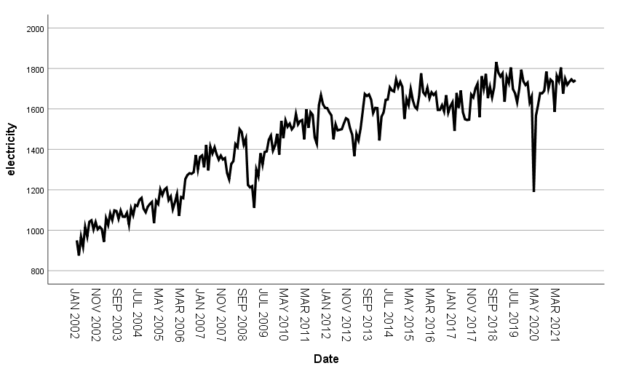 Figure 4.1: Original electricity generation plot
.
4.2.1 Testing for non-stationarity using ACF plot, PACF plot and Hypothesis testing
Figures 4.2 the ACF plot shows that all lags are significant. This is typical of non-stationary data. Figure 4.3 shows significant lags 1, 2, 5, 7, 11, 12, and 13. Figure 4.4 proves that the data is not stationary
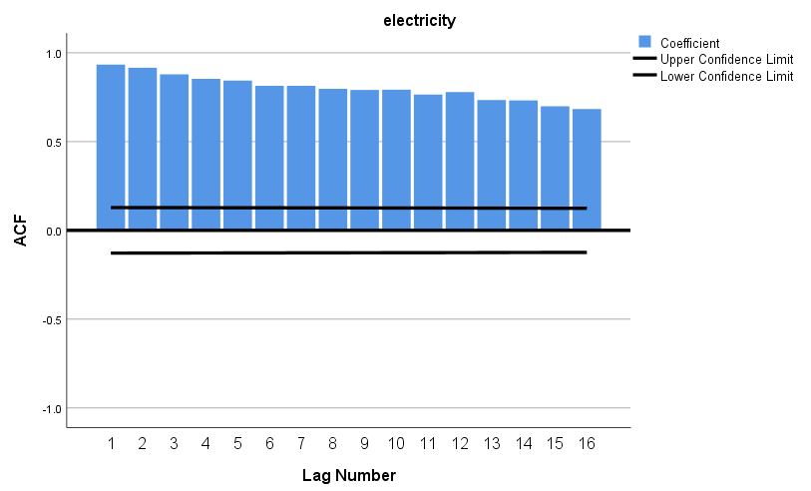
Figure 4.2 ACF of electricity generation:

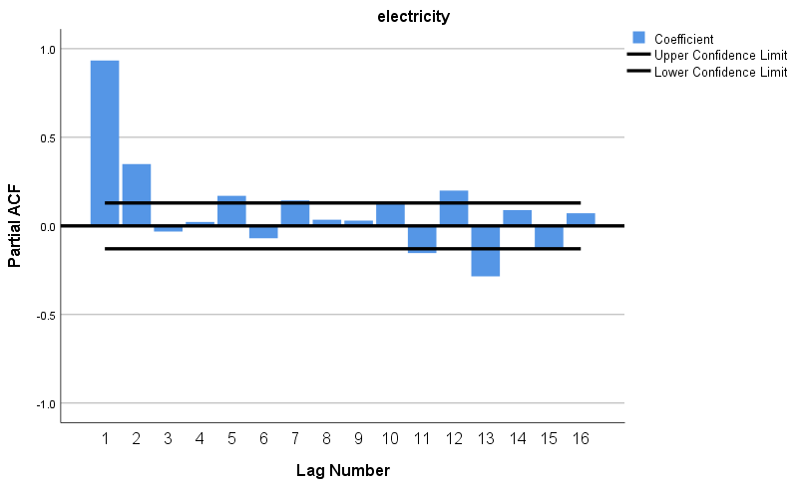
Figure 4.3 PACF of electricity generation:

Step 1:
H0: Data is not stationary
H1: Data is stationary
Step 2:
P-value = 0.41587
Step 3:
Fail to reject H0, not stationary
Table 4.13: hypothesis test for stationarity

4.2.3 First differenced electricity distribution plot
Figure 4.5 the plot of the differenced data shows that the mean is around 0, looks approximately stationary (at least the mean and variance are more-or-less constant) but it is not at all random (a strong seasonal pattern remains)
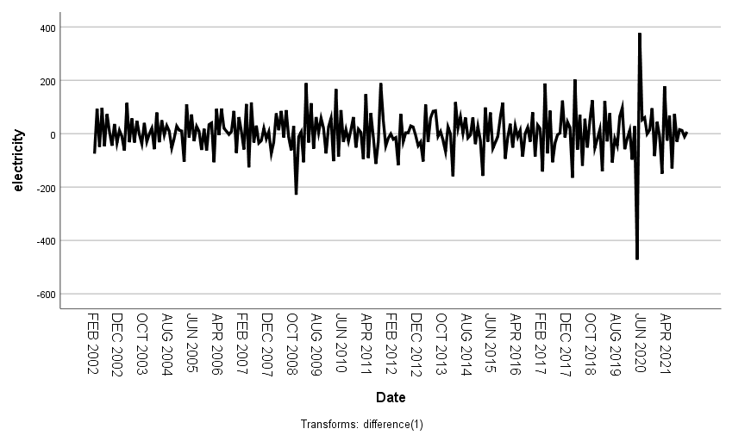
Figure 4.5 First differenced electricity distribution plot

4.2.4 ACF plot, PACF plot and stationarity hypothesis test of first differenced electricity plot
Figures 4.6 has significant lags 1, 2, 3, 5, 6, 7, 10, 11, 12, 13, 14, and 15. Since insignificant lags occur early as lag 3, 4 and 5 this indicates stationarity. Figure 4.7 there are significant spikes at lags 1, 4, 6, 7, 9, 10, 11, 12 and 14. And so stationarity is apparent here also as insignificant lags occur early on. Figure 4.8 indicates proves stationarity.
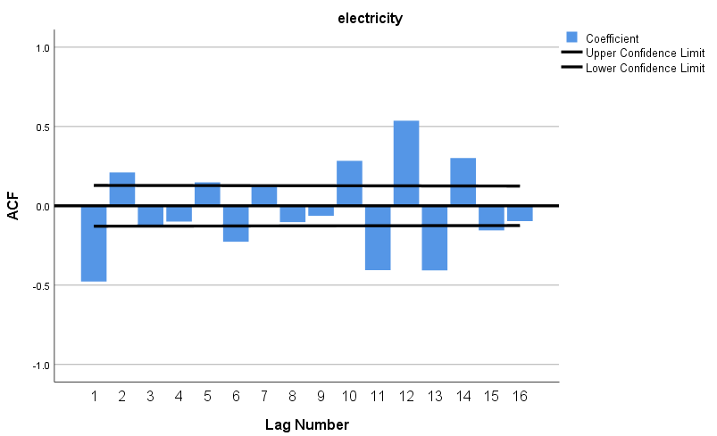
Figure 4.5 ACF of first differenced electricity generation:

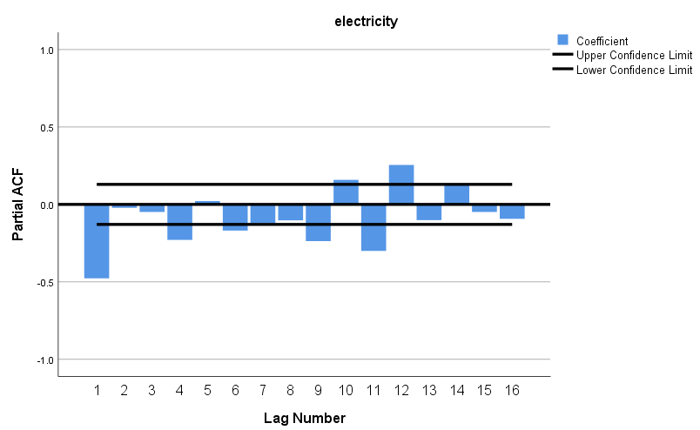
Figure 4.6 PACF of first differenced electricity generation:

Step 1:
H0: Data is not stationary
H1: Data is stationary
Step 2:
P-value = 0.000187
Step 3:
Reject H0, stationary
Table 4.13: hypothesis test for stationarity

4.2.5 First seasonal differenced electricity generation plot
Figure 4.9 The plot appears stationary without obvious signs of seasonality. (We should look at an autocorrelation plot to be sure that no seasonal pattern remains, but at least the gross seasonal pattern has been eliminated.)
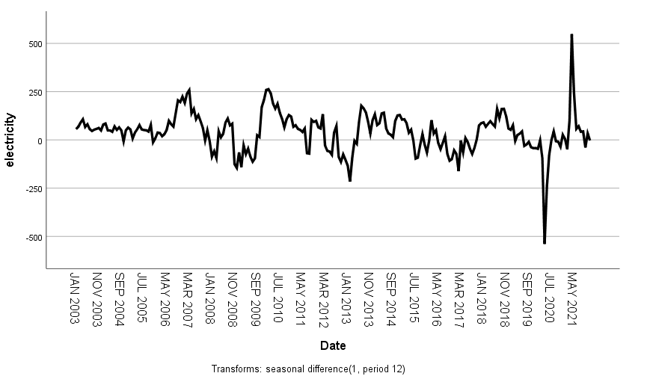 Figure 4.9 seasonal differenced electricity generation plot:

4.2.6 ACF and PACF plots of first seasonal differenced electricity distribution
Figure 4.10 shows significant lags namely 1, 2, 3, 4, 5, 6, 11, 12, 13, 14, 15 and 16. But these lags decrease quickly towards insignificance and 0. This indicates stationarity. Figure 4.11 there’s significant spikes at lags 1, 3, 11, 12, and 13. Figure 4.12 proves stationarity.
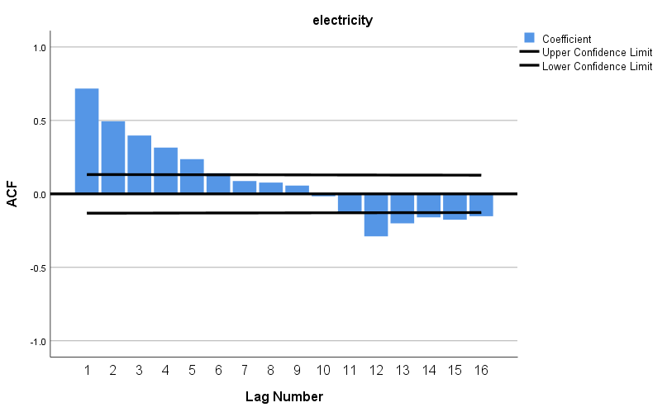
Figure 4.10 ACF plot of first seasonal differenced electricity generation plot:

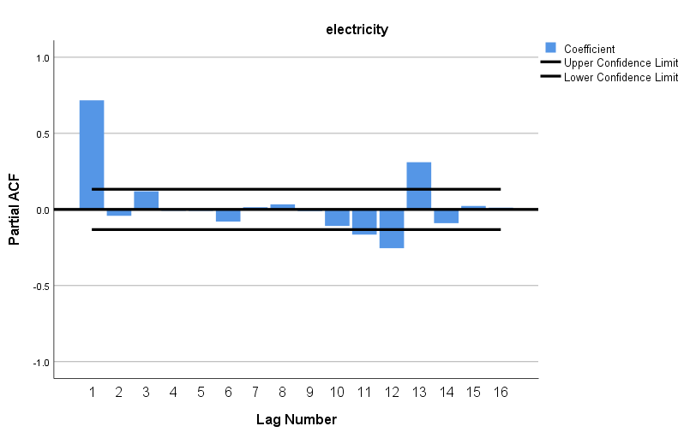
Figure 4.11 PACF plot of first seasonal differenced electricity generation plot:

Step 1:
H0: Data is not stationary
H1: Data is stationary
Step 2:
P-value = 0.004
Step 3:
Reject H0, stationary
Table 4.13: hypothesis test for stationarity

4.2.7 First differenced and seasonal differenced electricity distribution plot
Figure 4.13 appears stationary, and the mean look centred around 0.
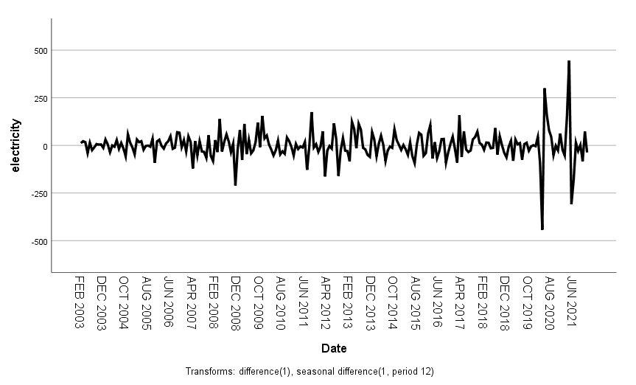
Figure 4.13 First differenced and seasonal differenced electricity generation plot

4.2.8 ACF and PACF plots of first differenced and seasonal differenced electricity distribution plots
Figure 4.14 Indicates only two significant lags, namely lag 2 and 12. This is also typical of stationarity. Figure 4.15 also has only two significant lags, namely lag 2, 11 and 12.
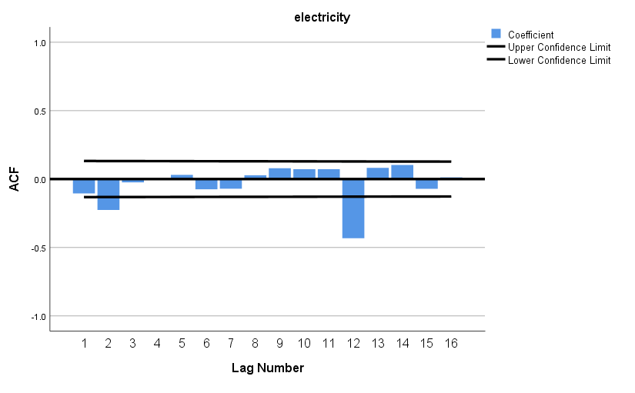
Figure 4.14 ACF of first differenced and seasonal differenced electricity generation plot
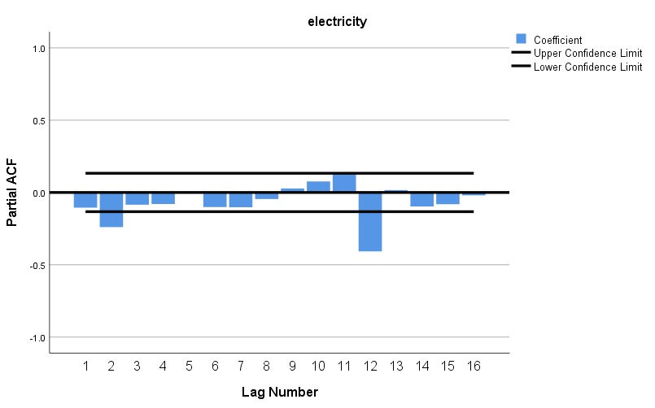 Figure 4.15 PACF of first differenced and seasonal differenced generation plot

4.2.9 Model identification
The possible ARIMA (p, d, q) ${(P, D, Q) }_{s}$ models are ARIMA (1, 1, 1) ${(1, 0, 1)}_{12}$, ARIMA (1, 0, 1) ${(1, 1, 1)}_{12}$ and ARIMA (2, 1, 1) ${(1, 1, 1)}_{12}$.
4.2.10 ARIMA models summary
Table 4.5 indicates the minimum as 875 which is the lowest number as 875, 25% of electricity distribution is less than 1271.5 (Q1), 50% of the data points are less than 1523.50 and 50% of the values are greater than 1523.50. 75% of the electricity is below 1665 and the maximum amount distributed is 1832. The energy distributed on average is 1456.20, the data is symmetrical based on the skewness.
Models | ARIMA (p, d, q) ${(P, D, Q) }_{s}$
1 | ARIMA (1, 1, 1) ${(1, 0, 1)}_{12}$
2 | ARIMA (1, 0, 1) ${(1, 1, 1)}_{12}$
3 | ARIMA (2, 1, 2) ${(1, 1, 1)}_{12}$
Table 4.1: ARIMA (p, d, q) (P, D, Q) s models of CPI
Minimum | Q 1 | Mean | Median | Q 3 | Maximum | Skewness
875 | 1271.5 | 1456.20 | 1523.50 | 1665 | 1832 | -0.554228
Table 4.2: Descriptive statistics of CPI
4.2.11 Model estimation
4.2.11.1 Estimating model 1
Figure 4.6 indicates that 94.8% (r squared) of the total variation in electricity distribution can be explained by the total variation in time, it is good since it is high. The weighted average error between the predictions and actual values (RMSE) is 55.777, and it is a good value. The (MAPE) indicates that on average the predictions are 2.563 away from the target, which is a good value. (MAE) shows that the average error between the predictions and actual values is 36.247 and it is a good value since the average electricity distribution is 1456.20. (MAXAPE) indicates that the predictions by 38.681% away from the actual values. (MAXAE) indicates the largest forecast error which is 459.916. (BIC) fit the model best and strike a good balance between the fit and the number of parameters used.
Model fit statistics | Model 1 Limpopo electricity distribution
R Squared | 0.948
RMSE | 55.777
MAPE | 2.563
MAE | 36.247
MAXAPE | 38.681
MAXAE | 459.916
BIC | 8.157
Table 4.3: Model fit statistics for model 1
4.2.11.2 Ljung-Box test statistics for model 1
In Table 4.7 p-value is greater than 0.05 thus is not significant, so model 1 does not show lack of fit,
H0: model does not show lack of fit
H1: model shows lack of fit
Ljung Box | Model 1 Limpopo electricity distribution
Statistics | 14.226
DF | 14
p-value | 0.433
Table 4.4: Ljung-Box test statistics for model 1
4.2.11.3 Parameter estimation for model 1

Model parameters | Estimates | SE | t | p-values
AR(1) | 0.690 | 0.067 | 10.274 | 0.000
MA(1) | -0.944 | 0.033 | 28.489 | 0.000
SAR(1) | 0.989 | 0.013 | 75.817 | 0.000
SMA(1) | 0.849 | 0.071 | 12.033 | 0.000
Table 4.5: Parameter estimates for model 1
4.2.11.4 Estimating model 2
Figure 4.6 indicates that 93.8% (r squared) of the total variation in electricity distribution can be explained by the total variation in time, it is good since it is high. The weighted average error between the predictions and actual values (RMSE) is 55.975, and it is a good value. The (MAPE) indicates that on average the predictions are 2.497 away from the target, which is a good value. (MAE) shows that the average error between the predictions and actual values is 36.426 and it is a good value since the average electricity distribution is 1456.20. (MAXAPE) indicates that the predictions by 38.547% away from the actual values. (MAXAE) indicates the largest forecast error which is 458.318. (BIC) of 8.169 fit the model best and strike a good balance between the fit and the number of parameters used.
Model fit statistics | Model 2 Limpopo electricity distribution
R Squared | 0.938
RMSE | 55.975
MAPE | 2.497
MAE | 36.426
MaxAPE | 38.547
MaxAE | 458.318
BIC | 8.169
Table 4.6: Model fit statistics for model 2
4.2.11.5 Ljung-Box test statistics for model 2
In Table 4.7 p-value is greater than 0.05 thus is not significant, so model 1 does not show lack of fit,
H0: model does not show lack of fit
H1: model shows lack of fit
Ljung Box | Model 2 Limpopo electricity distribution
Statistics | 16.624
DF | 14
p-value | 0.277
Table 4.7: Ljung-Box test statistics for model 2
4.2.11.6 Parameter estimation for model 2

Model parameters | Estimates | SE | t | p-values
AR(1) | 0.840 | 0.046 | 18.253 | 0.000
MA(1) | 0.056 | 0.082 | 0.677 | 0.499
SAR(1) | 0.53 | 0.096 | 0.547 | 0.585
SMA(1) | 0.867 | 0.081 | 10.670 | 0.000
Table 4.8: Parameter estimates for model 2

4.2.11.7 Estimating model 3
Figure 4.6 indicates that 94.1% (r squared) of the total variation in electricity distribution can be explained by the total variation in time, it is good since it is high. The weighted average error between the predictions and actual values (RMSE) is 54.601, and it is a good value. The (MAPE) indicates that on average the predictions are 2.450 away from the target, which is a good value. (MAE) shows that the average error between the predictions and actual values is 35.717 and it is a good value since the average electricity distribution is 1456.20. (MAXAPE) indicates that the predictions by 37.213% away from the actual values. (MAXAE) indicates the largest forecast error which is 442.459. (BIC) of 8.167 fit the model best and strike a good balance between the fit and the number of parameters used.
Model fit statistics | Model 3 Limpopo electricity distribution
R Squared | 0.941
RMSE | 54.601
MAPE | 2.450
MAE | 35.717
MaxAPE | 37.213
MaxAE | 442.459
BIC | 8.167
Table 4.9: Model fit statistics for model 3
4.2.11.8 Ljung-Box test statistics for model 3
In Table 4.10 In Table 4.7 p-value is greater than 0.05 thus is not significant, so model 1 does not show lack of fit,
H0: model does not show lack of fit
H1: model shows lack of fit
Ljung Box | Model 3 Limpopo electricity distribution
Statistics | 13.242
DF | 12
P-value | 0.352
Table 4.10: Ljung-Box test statistics for model 3
4.2.11.9 Parameter estimation for model 3

Model parameters | Estimates | SE | t | p-values
AR(1) | 0.059 | 0.945 | 0.062 | 0.950
AR(2) | 0.437 | 0.691 | 0.633 | 0.527
MA(1) | 0.333 | 25.781 | 0.013 | 0.990
MA(2) | 0.667 | 17.436 | 0.038 | 0.970
SAR(1) | 0.039 | 0.095 | 0.410 | 0.682
SMA(1) | 0.887 | 0.084 | 10.527 | 0.000
Table 4.11: Parameter estimates for model 3

4.2.12 Diagnostic checking
4.2.12.1 Diagnostic of model 1
Figure 4.16 indicates that the distribution is linear, thus the linearity and normality assumptions are not violated, figure 4.17 indicates a normal bell curve plot with thin tails. Figure 4.18 suggests that the residuals do not appear to be white noise, only one of the correlations are significantly different from 0. This is a good possible candidate model.
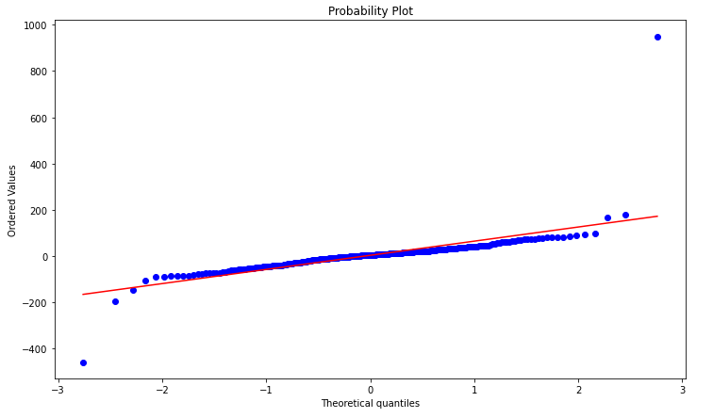
Figure 4.16 QQ plot for model 1

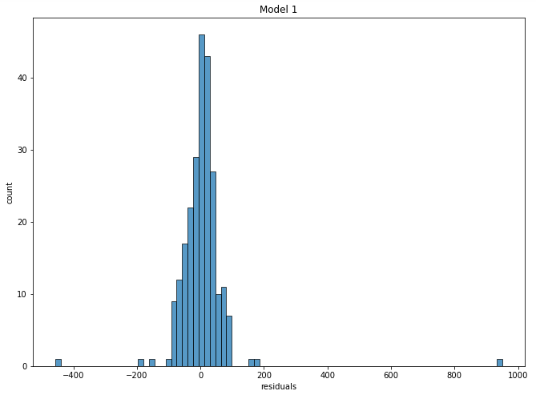
Figure 4.17 Histogram of residual for model 1

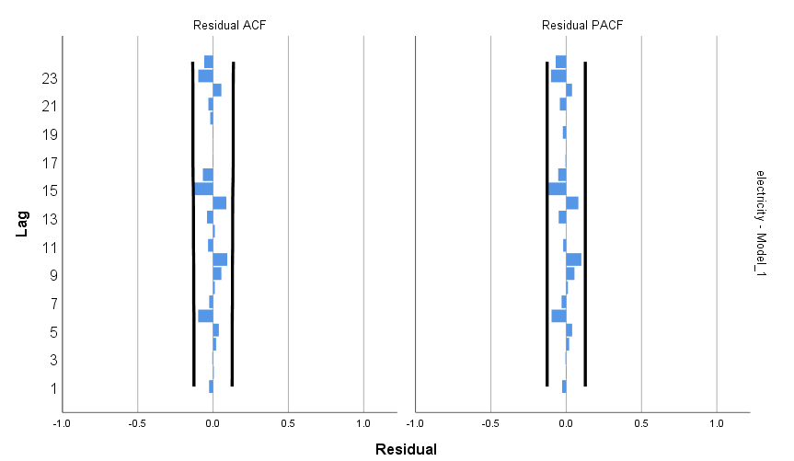
Figure 4.18 Residual ACF and PACF for model 1

4.2.12.2 Diagnostic of model 2
Figure 4.19 indicates no linear pattern thus linearity fails, figure 4.20 indicates normal bell curve plot with thin tails Figure 4.21 suggests that the residuals do not appear to be white noise, none of the correlations are significantly different from 0.
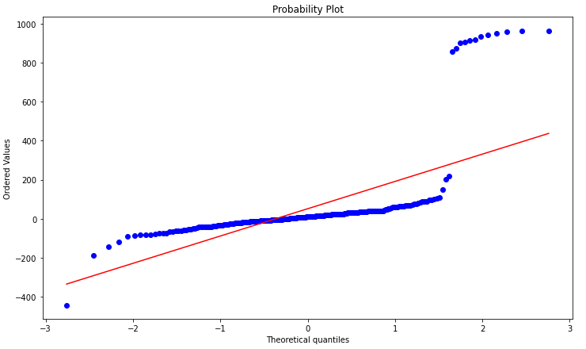
Figure 4.19 QQ plot for model 2

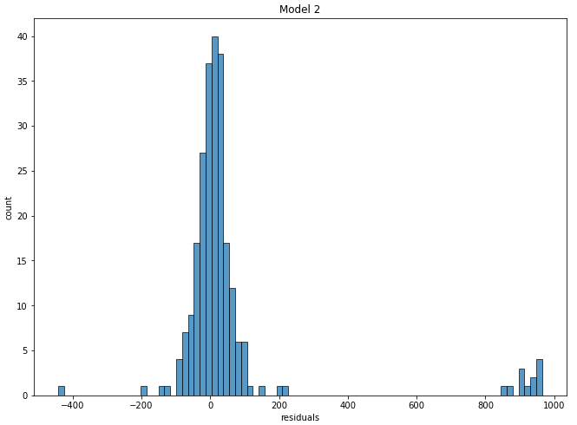
Figure 4.20 Histogram of residual for model 2

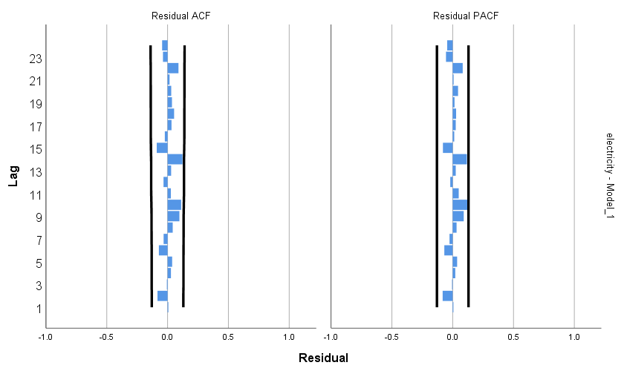
Figure 4.21 Residual ACF and PACF for model 2
4.2.12.3 Diagnostic of model 3
Figure 4.22 indicates that the distribution is linear, thus the linearity and normality assumptions are not violated, figure 4.23 indicates a normal bell curve plot with thin tails. Figure 4.24 suggests that the residuals do not appear to be white noise, only one of the correlations are significantly different from 0. This is a good possible candidate model.
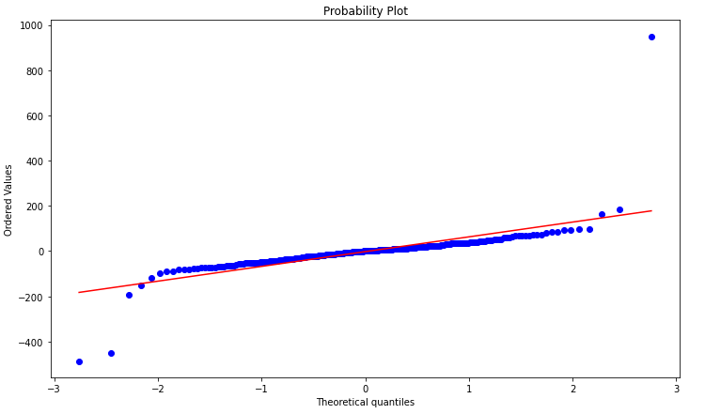
Figure 4.22 QQ plot for model 3

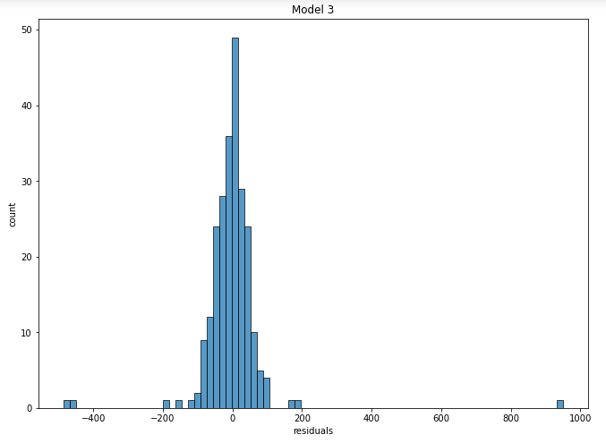
Figure 4.23 Histogram of residual for model 3

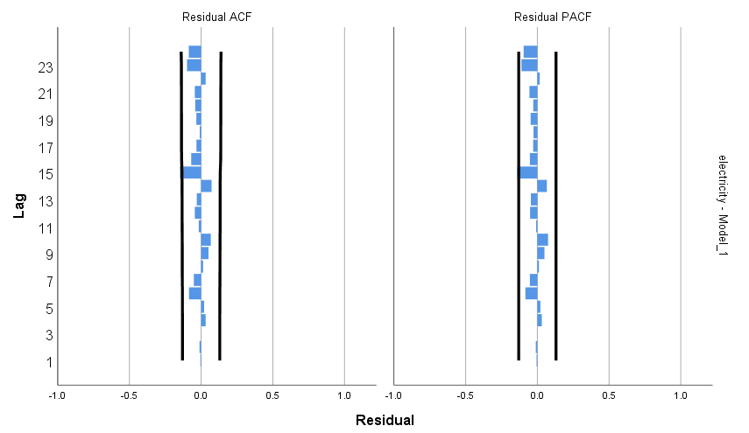
Figure 4.24 Residual ACF and PACF for model 3

4.2.13 Model selection
Table 4.12 indicates three models being compared, and the best model according to the table is model 3. It has the lowest RMSE, least MAE, smallest MAPE and best fit statistics. It only loses out on the BIC to model 1, otherwise it is the best.
ARIMA (p, d, q) (P, D, Q) s | BIC | RMSE | MAE | MAPE | Fit statistics
Model 1 | 8.157 | 55.777 | 36.247 | 2.563 | 14.226
Model 2 | 8.169 | 55.975 | 36.426 | 2.497 | 16.624
Model 3 | 8.167 | 54.601 | 35.717 | 2.450 | 12.900
Table 4.12: Accuracy measures for the different models

4.2.14 Best model of electricity distribution forecast at 95% confidence limit
Table 4.13 below indicates the predicted future values, along with the date, time, both lower and upper confidence limit at 95%.
Date | Time | Forecast | LCL | UCL
Jan 2022 | 1 | 1735 | 1629 | 1841
Feb 2022 | 2 | 1614 | 1483 | 1745
Mar 2022 | 3 | 1726 | 1585 | 1867
Apr 2022 | 4 | 1639 | 1492 | 1785
May 2022 | 5 | 1736 | 1587 | 1885
Jun 2022 | 6 | 1679 | 1529 | 1830
Jul 2022 | 7 | 1704 | 1553 | 1855
Aug 2022 | 8 | 1685 | 1534 | 1836
Sep 2022 | 9 | 1701 | 1549 | 1852
Oct 2022 | 10 | 1759 | 1608 | 1911
Nov 2022 | 11 | 1705 | 1553 | 1856
Dec 202 | 12 | 1713 | 1561 | 1864
Jan 2023 | 1 | 1714 | 1561 | 1867
Feb 2023 | 2 | 1598 | 1444 | 1752
Mar 2023 | 3 | 1711 | 1556 | 1865
Apr 2023 | 4 | 1622 | 1468 | 1777
May 2023 | 5 | 1722 | 1568 | 1877
Jun 2023 | 6 | 1669 | 1514 | 1824
Jul 2023 | 7 | 1692 | 1537 | 1847
Aug 2023 | 8 | 1674 | 1519 | 1829
Sep 2023 | 9 | 1689 | 1534 | 1845
Oct 2023 | 10 | 1750 | 1595 | 1905
Nov 2023 | 11 | 1693 | 1538 | 1848
Dec 2023 | 12 | 1701 | 1546 | 1856
Table 4.13: electricity distribution forecasts

4.2.15 Time series plot for electricity distribution with forecasts
Figure 4.25 indicates the electricity distribution plot with a forecast for the next 2 years. The predicted distribution seems to be stable, there’s also an upper and lower confidence limit that gets wider from the moment when forecasting starts to the end of the 2-year period.

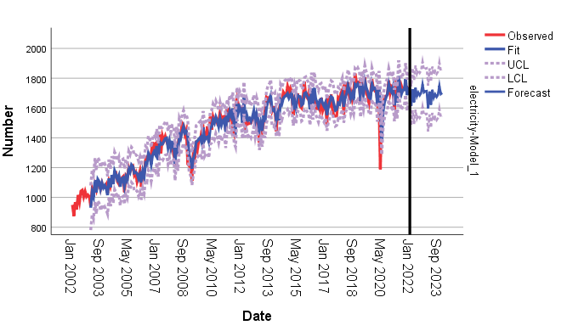
Figure 4.25 Time series plot for electricity distribution forecast

Chapter 5

Recommendations and Conclusion
5.1 Introduction
This chapter will discuss the results from the time series models described in the previous chapter to hypothesis the potential mechanisms by which the models can give valuable predictions relating to electricity generation.
5.2 Recommendations
Considering the results of factors associated with forecasting electricity generation in the study, the following recommendations are developed:
- There must be more investment into greener and reliable electrical energy sources, such as marine hydroelectric turbines. Ocean currents are free, always moving, and there’s no stoppage of electrical generation such as in solar power at night or cloudy days, wind power when there’s little to know wind. South Africa has one of the fastest and strongest flowing currents in the world running along its east coast: the Agulhas Current. South Africans should take advantage of this resource.
- Individuals should make efforts to rely less on the grid, and thus add solar panels to their roofs, small wind turbines.
5.3 Summary of findings
The objectives of this study were to contribute to the time series models literature by applying and comparing ARIMA models in short-term electricity generation. This will help to have a clear understanding as well as to acquire more knowledge about the factors that are associated with short-term electricity generation.
This study made use of the electricity distribution secondary data from Statistics South Africa ranging from January 2002 to May 2020. The study will focus on power generation in South Africa, with time and electricity generated in GWh as key variables. This data was found to be non-stationary using acf, pacf, line plots and a stationarity hypothesis test. So it was differenced to make it stationary. Then it was modeled into three models and the best models was chosen based on the individual metrics of each model.
The statistical software “R package”, Python and SPSS were used to analyze the data.Python was used for data cleaning, manipulation, feature engineering. R was used for hypothesis testing and SPSS was used for visualization, stats output, and modelling. More electricity seems to be generated as years go by, but there is still the occurrence of massive power drops on occasion despite the increasing trend of electricity generation. There were 240 entries in the data set.
5.4 Conclusion
Once the stated approach has been followed, an appropriate forecasted electricity generation results will help the country to better plan. The nation will be in clear terms on how to make decisions looking closely into the quantity of electricity generation and the economic state on the country. This might help in minimizing challenges in the future like load shedding.

Chapter 6

References

- Ahmed, R., Sreeram, V., Mishra, Y. and Arif, M.D., 2020. A review and evaluation of the state-of-the-art in PV solar power forecasting: Techniques and optimization. Renewable and Sustainable Energy Reviews, 124, p.109792.
- Amusa, H., Amusa, K. and Mabugu, R., 2009. Aggregate demand for electricity in South Africa: An analysis using the bounds testing approach to cointegration. Energy policy, 37(10), pp.4167-4175.
- Ateba, B.B., Prinsloo, J.J. and Gawlik, R., 2019. The significance of electricity supply sustainability to industrial growth in South Africa. Energy Reports, 5, pp.1324-1338.
- Bah, M.M. and Azam, M., 2017. Investigating the relationship between electricity consumption and economic growth: Evidence from South Africa. Renewable and Sustainable Energy Reviews, 80, pp.531-537.
- Banks, D. and Schäffler, J., 2005. The potential contribution of renewable energy in South Africa. Johannesburg, South Africa: Sustainable Energy & Climate Change Project (SECCP).
- Chikobvu, D. and Sigauke, C., 2013. Modelling influence of temperature on daily peak electricity demand in South Africa. Journal of Energy in Southern Africa, 24(4), pp.63-70.
- Chou, J.S. and Tran, D.S., 2018. Forecasting energy consumption time series using machine learning techniques based on usage patterns of residential householders. Energy, 165, pp.709-726.
- Competition, G.E.F., 2012. Wind forecasting. Accessed: Jun, 19, p.2021.
- de Oliveira, E.M. and Oliveira, F.L.C., 2018. Forecasting mid-long term electric energy consumption through bagging ARIMA and exponential smoothing methods. Energy, 144, pp.776-788.
- Dewa, M.T., Van Der Merwe, A.F. and Matope, S., 2020. Production scheduling heuristics for frequent load-shedding scenarios: a knowledge engineering approach. South African Journal of Industrial Engineering, 31(3), pp.110-121.
- Gaunt, C.T., 2008. Electricity distribution industry restructuring in South Africa: A case study. Energy policy, 36(9), pp.3448-3459.
- http://www.mastersindatascience.org/learning/what-is-arima-modeling/ website accessed on 06 April 2022
- Hyndman, R.J. and Athanasopoulos, G., 2018. Forecasting: principles and practice. OTexts.
- Inglesi-Lotz, R. and Blignaut, J.N., 2011. Estimating the price elasticity of demand for electricity by sector in South Africa. South African Journal of Economic and Management Sciences, 14(4), pp.449-465.
- Inglesi-Lotz, R. and Blignaut, J.N., 2012. Electricity intensities of the OECD and South Africa: A comparison. Renewable and Sustainable Energy Reviews, 16(7), pp.4491-4499.
- Inglesi, R., 2010. Aggregate electricity demand in South Africa: Conditional forecasts to 2030. Applied energy, 87(1), pp.197-204.
- Jain, S. and Jain, P.K., 2017. The rise of renewable energy implementation in South Africa. Energy Procedia, 143, pp.721-726.
- Javed, U., Ijaz, K., Jawad, M., Ansari, E.A., Shabbir, N., Kütt, L. and Husev, O., 2021. Exploratory Data Analysis Based Short-Term Electrical Load Forecasting: A Comprehensive Analysis. Energies, 14(17), p.5510.
- Kaytez, F., Taplamacioglu, M.C., Cam, E. and Hardalac, F., 2015. Forecasting electricity consumption: A comparison of regression analysis, neural networks and least squares support vector machines. International Journal of Electrical Power & Energy Systems, 67, pp.431-438.
- Khuntia, S.R., Rueda, J.L. and van Der Meijden, M.A., 2016. Forecasting the load of electrical power systems in mid-and long-term horizons: A review. IET Generation, Transmission & Distribution, 10(16), pp.3971-3977.
- Kuster, C., Rezgui, Y. and Mourshed, M., 2017. Electrical load forecasting models: A critical systematic review. Sustainable cities and society, 35, pp.257-270.
- Li, S., Yang, X. and Li, R., 2018. Forecasting China’s coal power installed capacity: a comparison of MGM, ARIMA, GM-ARIMA, and NMGM models. Sustainability, 10(2), p.506.
- Ma, M. and Wang, Z., 2019. Prediction of the energy consumption variation trend in South Africa based on ARIMA, NGM and NGM-ARIMA models. Energies, 13(1), p.10.
- Rajbhandari, Y., Marahatta, A., Ghimire, B., Shrestha, A., Gachhadar, A., Thapa, A., Chapagain, K. and Korba, P., 2021. Impact study of temperature on the time series electricity demand of urban nepal for short-term load forecasting. Applied System Innovation, 4(3), p.43.
- Spalding-Fecher, R. and Matibe, D.K., 2003. Electricity and externalities in South Africa. Energy policy, 31(8), pp.721-734.
- Umar, B.B. and Kunda-Wamuwi, C.F., 2019. Socio-Economic effects of load shedding on poor urban households and small business enterprises in Lusaka, Zambia. Energy and Environment Research, 9(2), pp.20-29.
- Wang, Y., Wang, J., Zhao, G. and Dong, Y., 2012. Application of residual modification approach in seasonal ARIMA for electricity demand forecasting: A case study of China. Energy Policy, 48, pp.284-294.
- Kaytez, F., Taplamacioglu, M.C., Cam, E. and Hardalac, F., 2015. Forecasting electricity consumption: A comparison of regression analysis, neural networks and least squares support vector machines. International Journal of Electrical Power & Energy Systems, 67, pp.431-438.
- Wang, H., Lei, Z., Zhang, X., Zhou, B. and Peng, J., 2019. A review of deep learning for renewable energy forecasting. Energy Conversion and Management, 198, p.111799.
- Zhang, J., Xia, X. and Alexander, D., 2008, September. Demand side optimal strategy for voluntary load shedding. In The second IASTED Africa conference on power and energy systems.
- Ziramba, E., 2008. The demand for residential electricity in South Africa. Energy policy, 36(9), pp.3460-3466.

Appendix: electricity distribution data from January 2002 to Feb 2022
Table 4.14 below displays the entire data set used in this research; it is arranged chronologically from 2002 January to 2021 December.
Date | Time | Limpopo electricity generation
JAN 2002 | 1 | 950
FEB 2002 | 2 | 875
MAR 2002 | 3 | 968
APR 2002 | 4 | 919
MAY 2002 | 5 | 1016
JUN 2002 | 6 | 969
JUL 2002 | 7 | 1042
AUG 2002 | 8 | 1049
SEP 2002 | 9 | 1004
OCT 2002 | 10 | 1040
NOV 2002 | 11 | 1005
DEC 2002 | 12 | 1017
JAN 2003 | 13 | 1006
FEB 2003 | 14 | 943
MAR 2003 | 15 | 1058
APR 2003 | 16 | 1026
MAY 2003 | 17 | 1083
JUN 2003 | 18 | 1050
JUL 2003 | 19 | 1098
AUG 2003 | 20 | 1095
SEP 2003 | 21 | 1057
OCT 2003 | 22 | 1097
NOV 2003 | 23 | 1067
DEC 2003 | 24 | 1066
JAN 2004 | 25 | 1086
FEB 2004 | 26 | 1028
MAR 2004 | 27 | 1107
APR 2004 | 28 | 1075
MAY 2004 | 29 | 1125
JUN 2004 | 30 | 1120
JUL 2004 | 31 | 1150
AUG 2004 | 32 | 1160
SEP 2004 | 33 | 1106
OCT 2004 | 34 | 1089
NOV 2004 | 35 | 1117
DEC 2004 | 36 | 1130
JAN 2005 | 37 | 1140
FEB 2005 | 38 | 1035
MAR 2005 | 39 | 1145
APR 2005 | 40 | 1130
MAY 2005 | 41 | 1202
JUN 2005 | 42 | 1174
JUL 2005 | 43 | 1201
AUG 2005 | 44 | 1210
SEP 2005 | 45 | 1149
OCT 2005 | 46 | 1167
NOV 2005 | 47 | 1104
DEC 2005 | 48 | 1138
JAN 2006 | 49 | 1178
FEB 2006 | 50 | 1071
MAR 2006 | 51 | 1164
APR 2006 | 52 | 1159
MAY 2006 | 53 | 1253
JUN 2006 | 54 | 1273
JUL 2006 | 55 | 1282
AUG 2006 | 56 | 1279
SEP 2006 | 57 | 1287
OCT 2006 | 58 | 1372
NOV 2006 | 59 | 1300
DEC 2006 | 60 | 1362
JAN 2007 | 61 | 1370
FEB 2007 | 62 | 1311
MAR 2007 | 63 | 1422
APR 2007 | 64 | 1296
MAY 2007 | 65 | 1413
JUN 2007 | 66 | 1380
JUL 2007 | 67 | 1410
AUG 2007 | 68 | 1375
SEP 2007 | 69 | 1349
OCT 2007 | 70 | 1369
NOV 2007 | 71 | 1350
DEC 2007 | 72 | 1357
JAN 2008 | 73 | 1283
FEB 2008 | 74 | 1252
MAR 2008 | 75 | 1328
APR 2008 | 76 | 1341
MAY 2008 | 77 | 1426
JUN 2008 | 78 | 1412
JUL 2008 | 79 | 1500
AUG 2008 | 80 | 1486
SEP 2008 | 81 | 1424
OCT 2008 | 82 | 1453
NOV 2008 | 83 | 1224
DEC 2008 | 84 | 1212
JAN 2009 | 85 | 1218
FEB 2009 | 86 | 1111
MAR 2009 | 87 | 1300
APR 2009 | 88 | 1267
MAY 2009 | 89 | 1381
JUN 2009 | 90 | 1325
JUL 2009 | 91 | 1387
AUG 2009 | 92 | 1390
SEP 2009 | 93 | 1448
OCT 2009 | 94 | 1468
NOV 2009 | 95 | 1394
DEC 2009 | 96 | 1419
JAN 2010 | 97 | 1477
FEB 2010 | 98 | 1374
MAR 2010 | 99 | 1541
APR 2010 | 100 | 1455
MAY 2010 | 101 | 1543
JUN 2010 | 102 | 1512
JUL 2010 | 103 | 1527
AUG 2010 | 104 | 1499
SEP 2010 | 105 | 1513
OCT 2010 | 106 | 1575
NOV 2010 | 107 | 1523
DEC 2010 | 108 | 1540
JAN 2011 | 109 | 1545
FEB 2011 | 110 | 1450
MAR 2011 | 111 | 1598
APR 2011 | 112 | 1507
MAY 2011 | 113 | 1584
JUN 2011 | 114 | 1571
JUL 2011 | 115 | 1458
AUG 2011 | 116 | 1428
SEP 2011 | 117 | 1617
OCT 2011 | 118 | 1668
NOV 2011 | 119 | 1622
DEC 2011 | 120 | 1605
JAN 2012 | 121 | 1604
FEB 2012 | 122 | 1583
MAR 2012 | 123 | 1568
APR 2012 | 124 | 1450
MAY 2012 | 125 | 1524
JUN 2012 | 126 | 1494
JUL 2012 | 127 | 1497
AUG 2012 | 128 | 1500
SEP 2012 | 129 | 1529
OCT 2012 | 130 | 1554
NOV 2012 | 131 | 1547
DEC 2012 | 132 | 1502
JAN 2013 | 133 | 1471
FEB 2013 | 134 | 1367
MAR 2013 | 135 | 1476
APR 2013 | 136 | 1445
MAY 2013 | 137 | 1504
JUN 2013 | 138 | 1588
JUL 2013 | 139 | 1674
AUG 2013 | 140 | 1664
SEP 2013 | 141 | 1672
OCT 2013 | 142 | 1647
NOV 2013 | 143 | 1580
DEC 2013 | 144 | 1605
JAN 2014 | 145 | 1604
FEB 2014 | 146 | 1444
MAR 2014 | 147 | 1562
APR 2014 | 148 | 1582
MAY 2014 | 149 | 1645
JUN 2014 | 150 | 1647
JUL 2014 | 151 | 1707
AUG 2014 | 152 | 1691
SEP 2014 | 153 | 1686
OCT 2014 | 154 | 1746
NOV 2014 | 155 | 1707
DEC 2014 | 156 | 1734
JAN 2015 | 157 | 1709
FEB 2015 | 158 | 1551
MAR 2015 | 159 | 1649
APR 2015 | 160 | 1619
MAY 2015 | 161 | 1698
JUN 2015 | 162 | 1643
JUL 2015 | 163 | 1610
AUG 2015 | 164 | 1599
SEP 2015 | 165 | 1660
OCT 2015 | 166 | 1776
NOV 2015 | 167 | 1682
DEC 2015 | 168 | 1668
JAN 2016 | 169 | 1705
FEB 2016 | 170 | 1653
MAR 2016 | 171 | 1682
APR 2016 | 172 | 1669
MAY 2016 | 173 | 1681
JUN 2016 | 174 | 1595
JUL 2016 | 175 | 1595
AUG 2016 | 176 | 1618
SEP 2016 | 177 | 1588
OCT 2016 | 178 | 1668
NOV 2016 | 179 | 1582
DEC 2016 | 180 | 1614
JAN 2017 | 181 | 1633
FEB 2017 | 182 | 1491
MAR 2017 | 183 | 1679
APR 2017 | 184 | 1605
MAY 2017 | 185 | 1691
JUN 2017 | 186 | 1584
JUL 2017 | 187 | 1549
AUG 2017 | 188 | 1545
SEP 2017 | 189 | 1547
OCT 2017 | 190 | 1671
NOV 2017 | 191 | 1657
DEC 2017 | 192 | 1701
JAN 2018 | 193 | 1724
FEB 2018 | 194 | 1559
MAR 2018 | 195 | 1762
APR 2018 | 196 | 1702
MAY 2018 | 197 | 1773
JUN 2018 | 198 | 1653
JUL 2018 | 199 | 1709
AUG 2018 | 200 | 1657
SEP 2018 | 201 | 1707
OCT 2018 | 202 | 1832
NOV 2018 | 203 | 1779
DEC 2018 | 204 | 1760
JAN 2019 | 205 | 1776
FEB 2019 | 206 | 1635
MAR 2019 | 207 | 1757
APR 2019 | 208 | 1728
MAY 2019 | 209 | 1805
JUN 2019 | 210 | 1697
JUL 2019 | 211 | 1678
AUG 2019 | 212 | 1633
SEP 2019 | 213 | 1697
OCT 2019 | 214 | 1794
NOV 2019 | 215 | 1736
DEC 2019 | 216 | 1718
JAN 2020 | 217 | 1730
FEB 2020 | 218 | 1633
MAR 2020 | 219 | 1661
APR 2020 | 220 | 1189
MAY 2020 | 221 | 1566
JUN 2020 | 222 | 1618
JUL 2020 | 223 | 1678
AUG 2020 | 224 | 1677
SEP 2020 | 225 | 1690
OCT 2020 | 226 | 1785
NOV 2020 | 227 | 1701
DEC 2020 | 228 | 1745
JAN 2021 | 229 | 1735
FEB 2021 | 230 | 1585
MAR 2021 | 231 | 1763
APR 2021 | 232 | 1737
MAY 2021 | 233 | 1805
JUN 2021 | 234 | 1675
JUL 2021 | 235 | 1749
AUG 2021 | 236 | 1719
SEP 2021 | 237 | 1734
OCT 2021 | 238 | 1746
NOV 2021 | 239 | 1735
DEC 2021 | 240 | 1742
Table 4.14: electricity distribution data

